Math 1210 #31
Length of a Curve and
Surface Area

Length of a Plane Curve
A plane curve is a curve that lies in a two-dimensional plane. We can define a plane curve using parametric equations. This means we define both x and y as functions of a parameter.

Parametric equations

Definition
A plane curve is smooth if it is given by a pair of parametric equations $x=f(t)$, and $y=g(t),t$ is on the interval $[a,b]$ where $f^{'}$ and $g^{'}$ exist and are continuous on $[a,b]$ and $f^{'}(t)$ and $g^{'}(t)$ are not simultaneously zero on ( $a,b$ ).

EX 1
Sketch the graph of the curve given by these parametric equations.
$$x=3t^{2}+2 y=2t^{2}-1 1≤t≤4$$

Arc length
We can approximate the length of a plane curve by adding up lengths of linear segments between points on the curve.
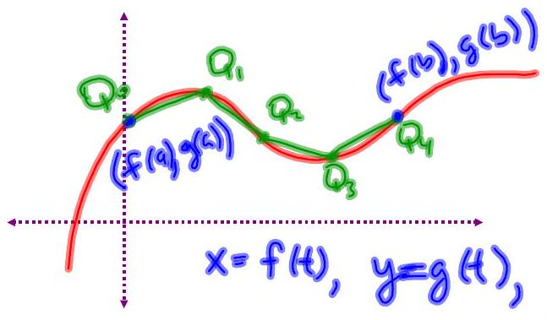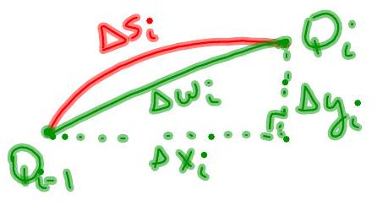
$$L=∫_{a}^{b} \sqrt{{\left[f^{'}(t)\right]}^{2}+{\left[g^{'}(t)\right]}^{2}}dt=∫_{a}^{b} \sqrt{{\left(\frac{dx}{dt}\right)}^{2}+{\left(\frac{dy}{dt}\right)}^{2}}dt \\ L=∫_{a}^{b} \sqrt{1+{\left(\frac{dy}{dx}\right)}^{2}}dx \\ L=∫_{c}^{d} \sqrt{1+{\left(\frac{dx}{dy}\right)}^{2}}dy$$

EX 2
Find the circumference of the circle $x^{2}+y^{2}=r^{2}$.
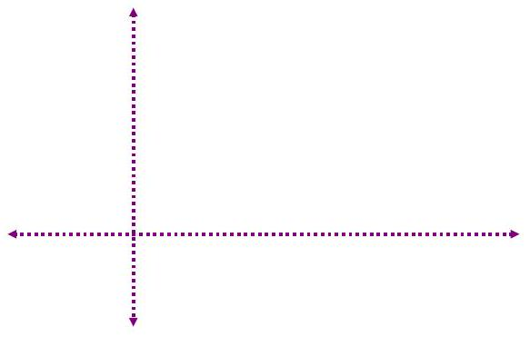

EX 3
Find the length of the line segment on $2y-2x+3=0$ between $y=1$ and $y=3$. Check your answer using the distance formula.

EX 4
Find the arc length of the curve $f(x)=\sqrt{x}$ from $x=0$ to $x=4$.

Surface Area
Differential of Arc Length
Let $f(x)$ be continuously differentiable on $[a,b]$. Start measuring arc length from ( $a,f(a)$ ) up to ( $x,f(x)$ ), where $a$ is a real number. Then, the arc length is a function of x .
accumulate arc length
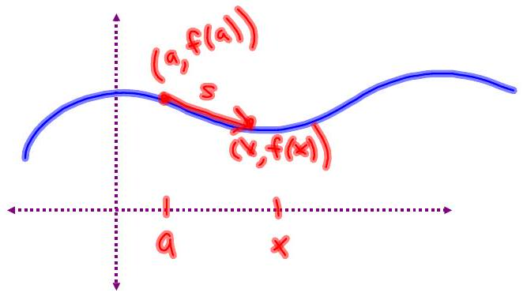
$$s(x)=\int_{a}^{x}{ }\sqrt{1+{\left(f^{'}(t)\right)}^{2}}dt$$

Surface Area of a Surface of Revolution
Rotate a plane curve about an axis to create a hollow three-dimensional solid.
Find the surface area of the solid.
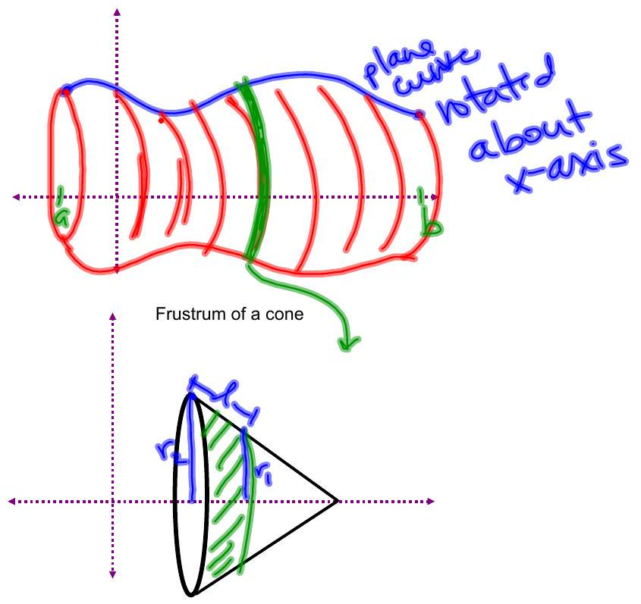

EX 4
Find the area of the surface generated by revolving $y=\sqrt{25-x^{2}}$ on the interval $[-2,3]$ about the $x$-axis.
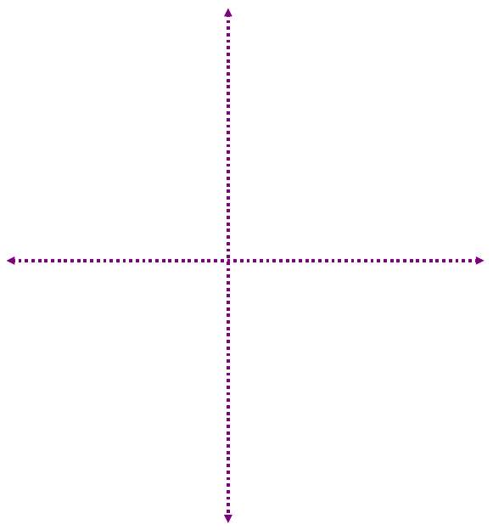

EX 5
Find the area of the surface generated by revolving $x=1-t^{2},y=2t$, on the t -interval $[0,1]$ about the x -axis.

