Math 1210 #33
Moments, Center of Mass
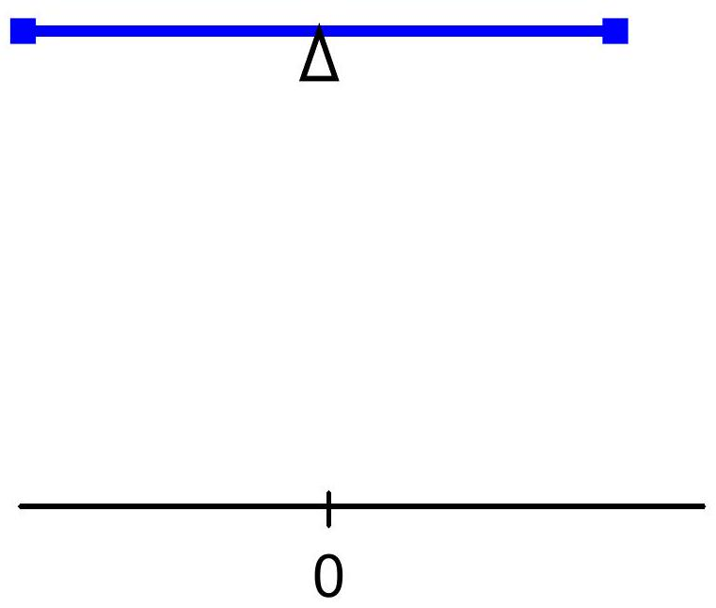

The moment of a particle with respect to a point is the product of mass $\left(m\right)$ of the particle with its directed distance $\left(x\right)$ from a point. This measures the tendency to produce a rotation about that point.
$$\text{Total moment (M) for a bunch of masses} =\sum_{i=1}^{n}{ }x_{i}m_{i}$$
$$x_{i}=\text{distance from 0 to particle} i$$

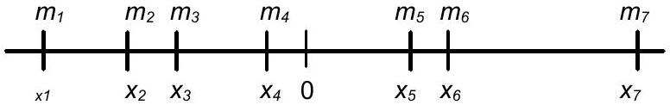

Where does the fulcrum need to be placed to balance? Let’s call it $\overline{x}$.
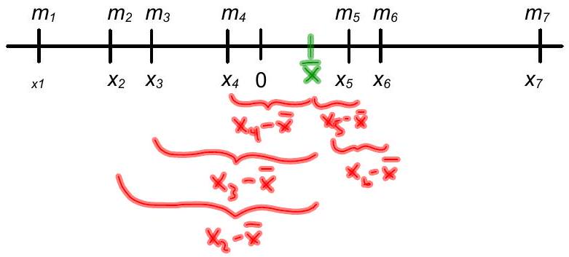

EX 1
John and Mary, weighing 180 lbs and 110 lbs respectively, sit at opposite ends of a $12ft$ teeter-totter with the fulcrum in the middle. Where should their $50 lb$ son sit in order for the board to balance?

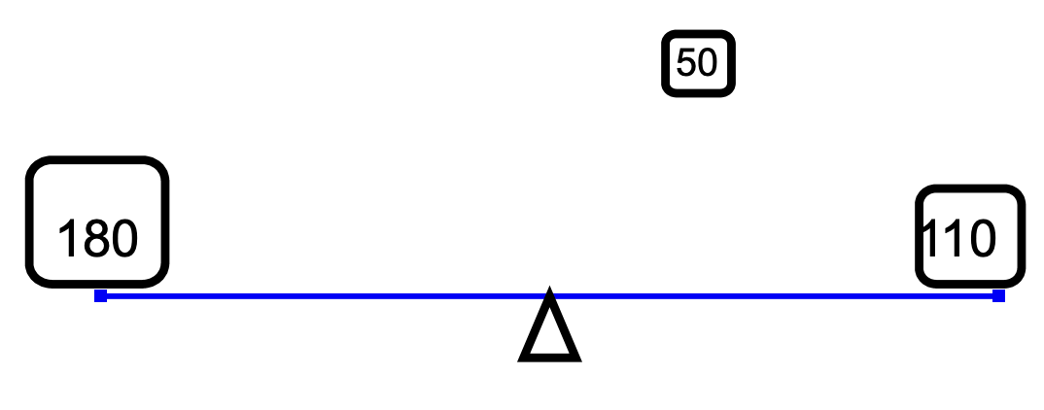

For a continuous mass distribution along the line (like on a wire):
$$\begin{matrix} & \overset{‾}{x}=\frac{M}{m}=\frac{\int_{a}^{b}{ } xδ\left(x\right)dx}{\int_{a}^{b}{ } δ\left(x\right)dx} \\ & \end{matrix}$$
($δ\left(x\right)$ is density function)
Since total mass = $\int_{a}^{b}{δ\left(x\right)dx}$
And moment is $\int_{a}^{b}{xδ\left(x\right)}dx$

EX 2
A straight wire 7 units long has density $δ\left(x\right)=1+x^{3}$ at a point $x$ units from one end. Find the distance from this end to the center of mass.
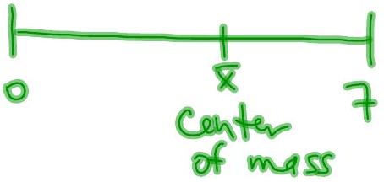

Consider a discrete set of 2-d masses.
How do we find the center of mass (the geometric center) $\left(\overset{‾}{x},\overset{‾}{y}\right)$ ?
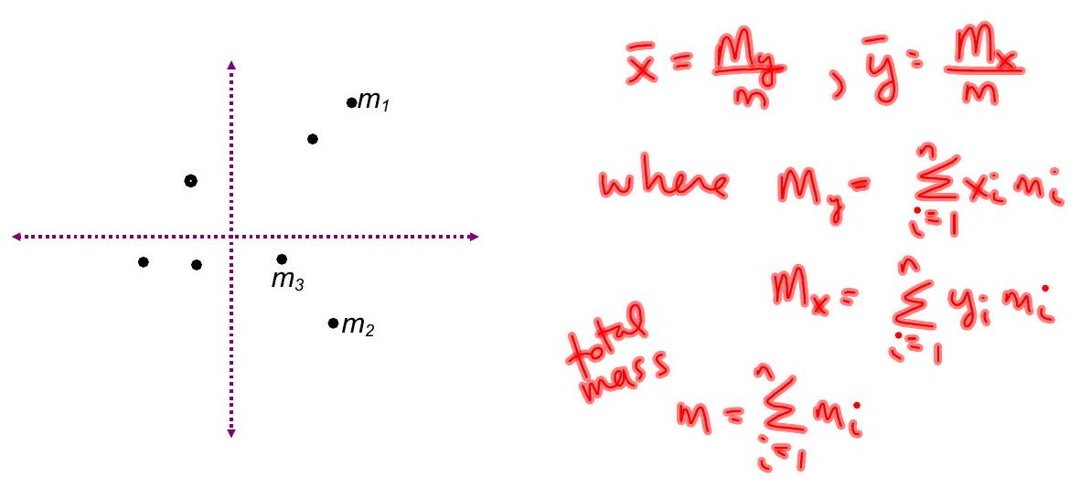

EX 3
The masses and coordinates of a system of particles are given by the following: $5,\left(-3,2\right);6,\left(-2,-2\right);2,\left(3,5\right);7,\left(4,3\right);1,\left(7,-1\right)$. Find the moments of this system with respect to the coordinate axes and find the center of mass.
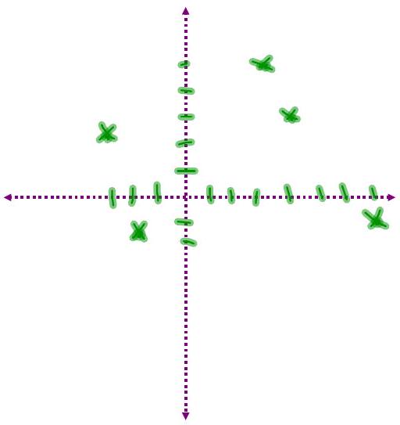

Now, consider a continuous region 2-d region (a lamina) that has constant (homogeneous) density everywhere. How do we find the center of mass $\left(\overline{x},\overline{y}\right)$?
It's still true $\overset{‾}{x}=\frac{m_{x}}{m},\overset{‾}{y}=\frac{m_{y}}{m}$
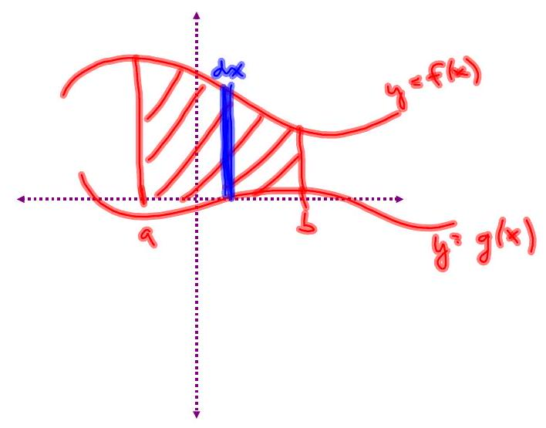
Total mass
$$m=\int_{a}^{b}{ }δ\left(f\left(x\right)-g\left(x\right)\right)dx$$
(density - area)
$δ=$ density (per area unit)

EX 4
Find the centroid of the region bounded by $y=x^{2}$ and $y=x+2$.
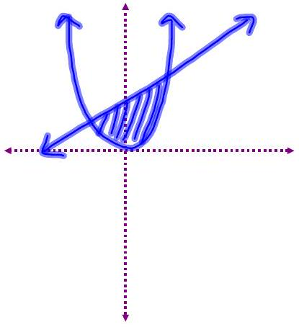

Two Children of Equal Mass
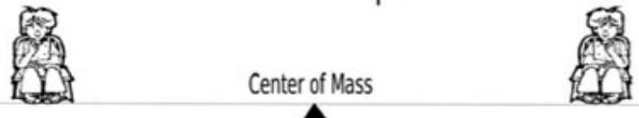
One Highschooler and One Elementary Schooler

One Baby and One Cow
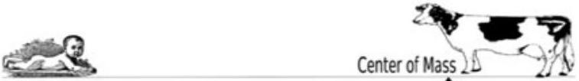
One Planet and One Star
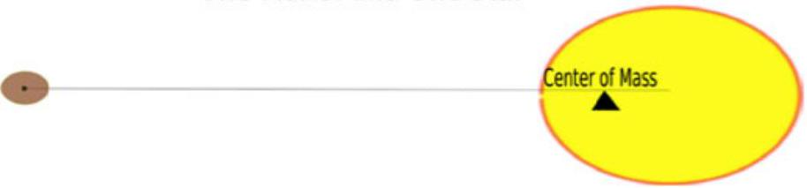
Photo source: Laboratory for Atmospheric and Space Physics, University of Colorado at Boulder

