Math 1210 #34
Numerical Integration

If $f\left(x\right)$ is continuous, we are guaranteed that $\int_{a}^{b}{f\left(x\right)dx}$ exists, but sometimes we cannot evaluate the integral. For these cases, we use numerical methods to approximate the definite integral (area under the curve.)

Left Riemann Sum
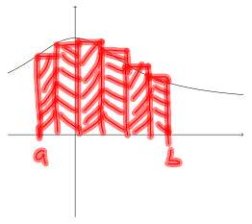

Right Riemann Sum
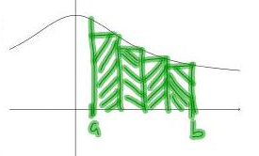
Area of n-th rectangle = $f\left(x_{n}\right)Δx_{n}$
Let all $Δx_{n}=Δx$
$Δx=\frac{b-a}{n}$, $x_{i}=a+iΔx$

$$\int_{a}^{b}{f\left(x\right)dx}≈\frac{b-a}{n}\sum_{i=1}^{n}{f\left(a+i\left(\frac{b-a}{n}\right)\right)}$$

Error: $E_{n}=-\frac{{\left(b-a\right)}^{2}}{2n}f^{'}\left(c\right)$ for some $c∈\left[a,b\right]$

Midpoint Riemann Sum
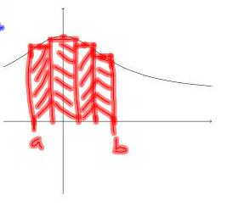

Area of n-th rectangle $= f\left(\frac{x_{i-1}+x_{i}}{2}\right) \text{Δx}$
$$Δx = \frac{b-a}{n}$$
$$x_{i} = a + iΔx$$
$$x_{i-1} = a + (i-1)Δx$$
$$⇒\frac{ x_{i}x_{i-1}}{2} = \frac{a+iΔx+a+\left(i-1\right)Δx}{2}$$
$$= \frac{2a+2iΔx-Δx}{2}$$
$$= a + iΔx - \frac{1}{2}Δx$$

4. Trapezoidal Rule
area of $n^{\text{th} }$ trapezoid $=\frac{1}{2}\left(f\left(x_{i}\right)+f\left(x_{i-1}\right)\right)Δx$
$$Δx=\frac{b-a}{n},{ x}_{i}=a+iΔx$$
$$x_{i+1}=a+\left(i-1\right)Δx$$

$$\int_{a}^{b}{ }f\left(x\right)dx≈\frac{1}{2}\left(\frac{b-a}{a}\right)\sum_{i=1}^{n}{\left[f\left(x_{\left(-1\right)}\right)+f\left(x\right)\right]}$$
Area of right trapezoid:
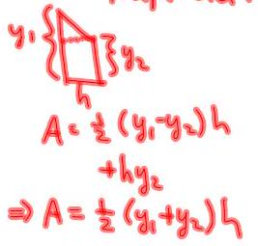

5. Simpon’s Rule
(aka. Parabolic Rule)
[Typed text follows this image].
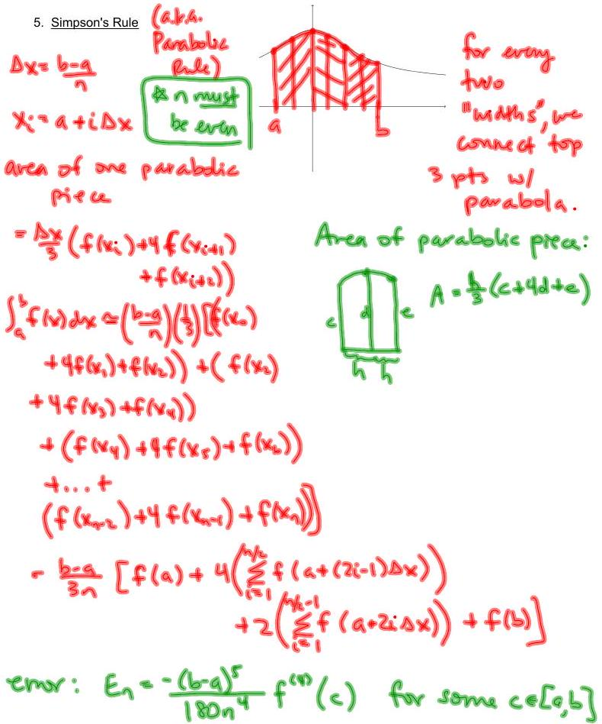
★ n must be even
for every two "widths", we connect top 3 pts w/ parabola.
$$Δx=\frac{b-a}{n}$$
$$x_{i}=a+iΔx$$
area of one parabolic piece = $\frac{Δx}{3}\left(f\left(x_{i}\right)+4f\left(x_{i+1}\right)+f\left(x_{i+2}\right)\right)$
$$\int_{a}^{b}{f}\left(x\right) dx≈\left(\frac{b-a}{n}\right)\left(\frac{1}{3}\right)\left[\begin{matrix}\left(f\left(x_{0}\right)+4f\left(x_{1}\right)+f\left(x_{2}\right)\right) \\ +\left(f\left(x_{2}\right)+4f\left(x_{3}\right)+f\left(x_{4}\right)\right) \\ +\left(f\left(x_{4}\right)+4f\left(x_{5}\right)+f\left(x_{6}\right)\right) \\ +...+\left(f\left(x_{n-2}\right)+4f\left(x_{n-1}\right)+f\left(x_{n}\right)\right)\end{matrix}\right]$$
= $\frac{b-a}{3n}\left[\begin{matrix}f\left(a\right)+4\left(\sum_{i=1}^{\frac{n}{2}}{f}\left(a+\left(2i-1\right)Δx\right)\right) \\ +2\left(\sum_{i=1}^{\frac{n}{2}-1}{f}\left(a+2iΔx\right)\right)+f\left(b\right)\end{matrix}\right]$
error: $E_{n}=-\frac{{\left(b-a\right)}^{5}}{180n^{4}}f^{\left(4\right)}\left(c\right)$ for some $c∈\left[a,b\right]$

EX 1
Use methods 2, 4 and 5 to approximate this integral. $\int_{1}^{3}{ } \frac{1}{x^{3}}dx$ Let $n=8$

Right Rectangular Method

$\int_{1}^{3}{ } \frac{1}{x^{3}}dx$ Let $n=8.$ Trapezoidal Rule

$\int_{1}^{3}{ }\frac{1}{x^{3}}dx$ Let n = 8. Simpson's Rule

Actual Value
$$\int_{1}^{3}{ }\frac{1}{x^{3}}dx$$
