Math 1210 #3
Limit Theorems

Limit Theorems
$n$ is a positive integer.
$k$ is a real number
$f(x) \& g(x)$ have limits as $x→c$
- $\lim_{x→c} k=k$
- $\lim_{x→c} x=c$
- $\lim_{x→c} \left[kf\left(x\right)\right]=k\lim_{x→c} f\left(x\right)$
- $\lim_{x→c} \left[f\left(x\right)±g\left(x\right)\right]=\lim_{x→c} f\left(x\right)±\lim_{x→c} g\left(x\right)$
- $\lim_{x→c} \left[f\left(x\right)g\left(x\right)\right]=\lim_{x→c} f\left(x\right)\lim_{x→c} g\left(x\right)$
- $\lim_{x→c} \frac{f\left(x\right)}{g\left(x\right)}=\frac{\lim_{x→c} f\left(x\right)}{\lim_{x→c} g\left(x\right)},g\left(x\right)≠0$
- $\lim_{x→c} [f(x)]^{n}={\left[\lim_{x→c} f\left(x\right)\right]}^{n}$
- $\lim_{x→c} \sqrt[n]{f\left(x\right)}=\sqrt[n]{\lim_{x→c} f\left(x\right)}$, if $\lim_{x→c} f\left(x\right)>0$ when $n$ is even.

EX 1
$$\lim_{x→2} \left(4x^{2}-2x+1\right)$$

EX 2
$$\lim_{x→-3} \frac{\sqrt{x^{2}-1}}{2x}$$

EX 3
If $\lim_{x→a} f\left(x\right)=3$ and $\lim_{x→a} g\left(x\right)=-1$, find $\lim_{x→a} \frac{2f\left(x\right)-3g\left(x\right)}{f\left(x\right)+g\left(x\right)}$

Substitution Theorem
If $f\left(x\right)$ is a polynomial or a rational function, then $\lim_{x→c} f\left(x\right)=f\left(c\right)$ assuming $f\left(c\right)$ is defined.

EX 4

$$\lim_{x→-1} \frac{3x^{2}-4x^{3}+7x-5}{2x^{2}+3x+4}$$

EX 5
$$\lim_{x→2} \frac{3x^{3}+4x+1}{x^{2}-x-2}$$

EX 6
$\lim_{x→0} \frac{\sqrt{x+1}-1}{x}$ Hint: rationalize the numerator.

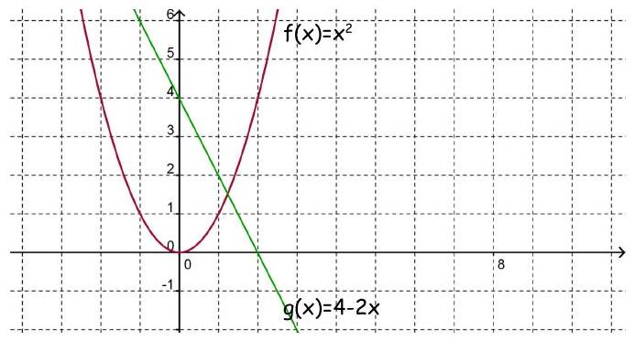
$$\lim_{x→1} f\left(x\right)= \\ \lim_{x→1} g\left(x\right)= \\ \lim_{x→1} f\left(x\right)-g\left(x\right)=?$$
