Math 1210 #4a
Limits At Infinity, Infinite Limits

Definition: (Limit as x→∞ )
is defined on $[c,∞)$ for $c∈R$
We say that if for every $ε>0$ there is a corresponding number, $m$ such that
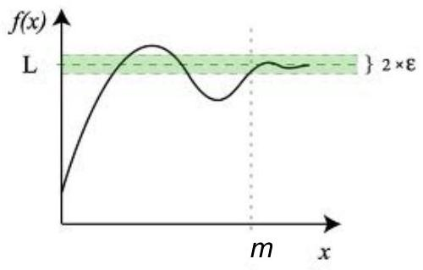

EX 1
Intuitively (looking at the graph) determine these limits.
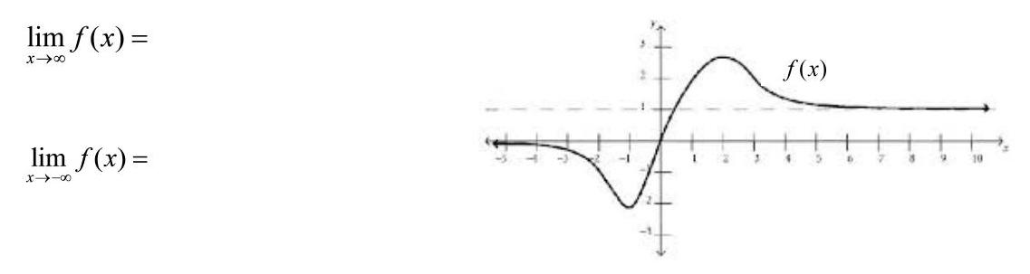

EX 2
Show that if $n$ is a positive integer, then $\lim_{x→∞} \frac{1}{x^{n}}=0$.

EX 3
$$\lim_{x→∞} \frac{2x+3}{x^{2}+1}=$$

EX 4
$$\lim_{x→∞} \frac{3x^{4}-2x^{3}+53}{x^{3}+7}=$$

EX 5
$$\lim_{x→∞} \frac{2x^{2}+5x-1}{x^{2}+3x}=$$

Definition: (Infinite limit)
We say $\lim_{x→c^{+}} f(x)=∞$ if for every positive number, m there is a corresponding $δ>0$ such that $0<x-c<δ⇒f(x)>m$

EX 6
Determine these limits looking at this graph of $f(x)=\frac{1}{x-1}$.
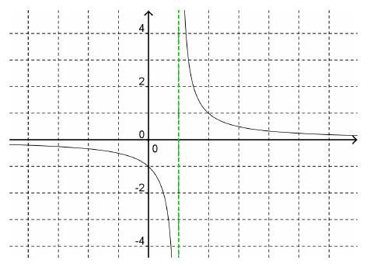

$$\begin{matrix}\lim_{x→∞} f(x)= & \lim_{x→1^{+}} f(x)= \\ \lim_{x→-∞} f(x)= & \lim_{x→1^{-}} f(x)=\end{matrix}$$

EX 7
Find the horizontal and vertical asymptotes for this function, then write a few limit statements including $∞. f(x)=\frac{-2x}{x+3}$

EX 8

8a)
Find the vertical and horizontal asymptotoes for this function.
$$f(x)=\frac{2x}{\sqrt{x^{2}+5}}$$

8b)
Determine these limits:
$$\begin{matrix}\lim_{x→∞} f(x)= & \lim_{x→\sqrt{5^{+}}} f(x)= \\ \lim_{x→-∞} f(x)= & \lim_{x→\sqrt{5}} f(x)=\end{matrix}$$

Determine these limits:
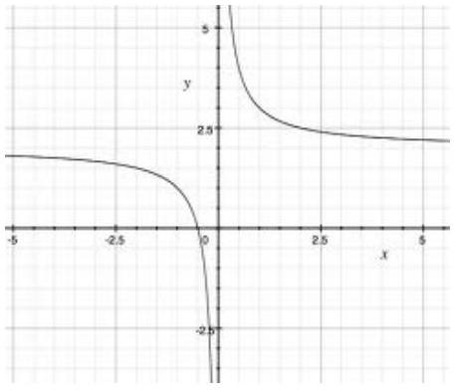
$$\begin{matrix} & \lim_{x→∞} f(x)= \\ & \lim_{x→0^{+}} f(x)= \\ & \lim_{x→-∞} f(x)= \\ & \lim_{x→0^{-}} f(x)=\end{matrix}$$

