Math 1210 #6
Continuity

Definition: Continuity at a Point
Let $f$ be defined on an open interval containing $c$. We say that $f$ is continuous at $c$ if
$$\lim_{x→c} f(x)=f(c)$$
This indicates three things:
- The function is defined at $x=c$.
- The limit exists at $x=c$.
- The limit at $x=c$ needs to be exactly the value of the function at $x=c$.
Three examples:
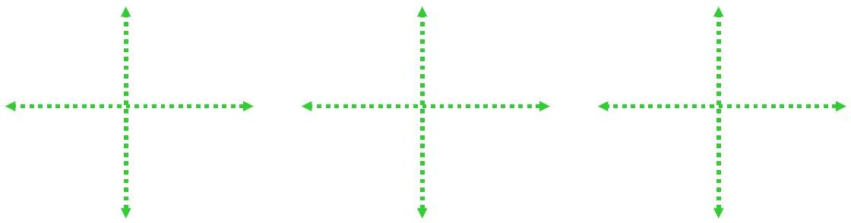

Continuous Functions
- All polynomial functions are continuous everywhere.
- All rational functions are continuous over their domain.
- The absolute value function is continuous everywhere.
- $f(x)=\sqrt[n]{x}$ is continuous for all real numbers if n is odd.
- $f(x)=\sqrt[n]{x}$ is continuous for all non-negative real numbers if n is even.
- The sine and cosine functions are continuous over all real numbers.
- The cotangent, cosecant, secant and tangent functions are continuous over their domain.

More continuous functions
If $f(x)$ and $g(x)$ are continuous at $x=c$, then so are
$$\begin{matrix}kf(x), (f±g)(x), (fg)(x), \frac{f}{g}(x),(g(x)≠0) \\ f^{n}(x), \sqrt[n]{f(x)}, (f(c)>0 \text{if }\text{niseven} )\end{matrix}$$

EX 1
State where these functions are continuous.

1a)
$f(x)=x^{2}-9$

1b)
$g(x)=\sqrt{x-5}$

1c)
$h(x)=\frac{21-7x}{x-3}$

1d)
$p(x)=\left\{\begin{matrix}7-3x & x≤3 \\ -2 & x>3\end{matrix}\right.$

Composite Limit Theorem
If $\lim_{x→c} g(x)=L$ and $f$ is continuous at $L$, then $\lim_{x→c} f(g(x))=f\left(\lim_{x→c} g(x)\right)=f(L)$

EX 2
At what points are the following functions continuous?

2a)
$h(x)=\frac{1}{\sqrt{4+x^{2}}}$

2b)
$g(t)=|t-2|$

EX 3
If $f(x)=\frac{x^{2}-49}{x-7}$, how do we need to complete the definition for this to be continuous everywhere?

Intermediate Value Theorem
$f$ is a function defined on $[a,b]$ and $ω$ is a number between $f(a)$ and $f(b)$.
If $f$ is continuous on $[a,b]$, then there exists at least one number, $c$, $(a<c<b)$ such that $f(c)=ω$.

Use interval notation to state all values for which this function is continuous.
