Math 1210 #7
Calculus: The Slope of A Curve

How do we find the slope of a curve?

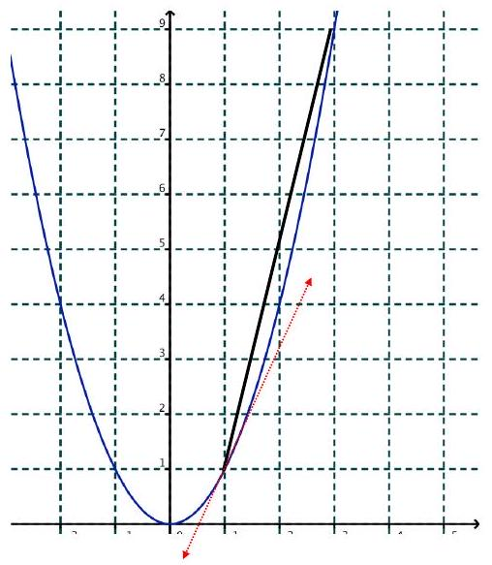
Try to find the slope of this curve at the point $(1,1)$.
First point $(1,1)$
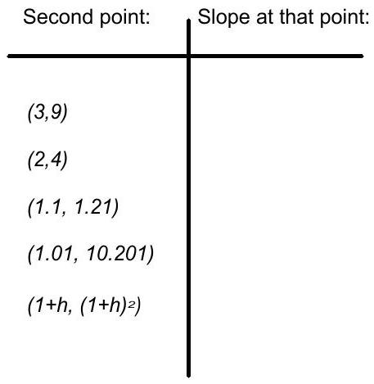

Slope to the left of the origin?

Slope to the right of the origin?

EX 1
Find the slope of the curve $y=x^{2}-5x$ at $(2,-6)$
hint: Calculate the slope between $(2,-6)$ and $(2+h,f(2+h))$

Definition
The slope of a function, $f$, at a point $x=(x,f(x))$ is given by
$$m=f^{'}(x)= \lim_{h→0} \frac{f(x+h)-f(x)}{h}$$
$f^{'}(x)$ is called the derivative of $f$ with respect to $x$.
Other names for $f^{'}(x)$ :
slope
instantaneous rate of change
speed
velocity

EX 2
Find the derivative of $f(x)=4x-1$

EX 3
Find the derivative of $f(x)=x^{2}+4x-1$

What is the slope at point $P$ ?
