Math 1210 #8
Two Problems, One Theme
It took me 6 hours to drive 400 miles. As I drove I wrote the mileage on the trip-o-meter each half hour. Here is a graph of my trip.
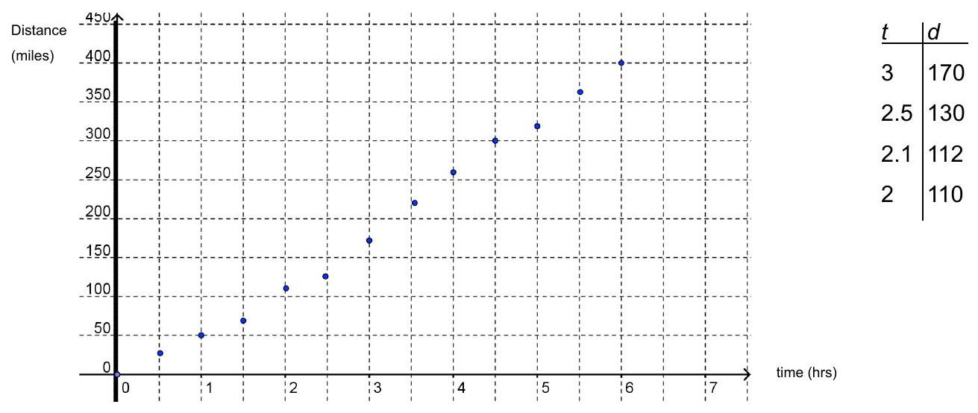

What was my average velocity for the trip? $v_{av}=$
What was my average velocity for the first half of the trip?
How fast was I going at $t=2$? $v_{\text{inst} }=$

Archimedes - slope of a tangent line.
Kepler, Galileo, Newton - Instantaneous velocity.
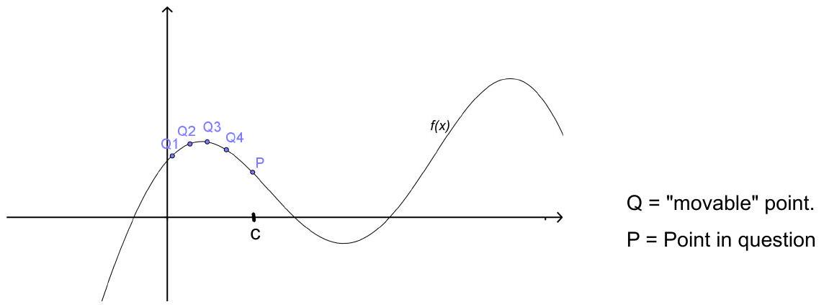

secant line ⇒ line through $P$ and $Q$.
tangent line⇒ limiting position (if it exists) of secant line as Q moves closer to P along the curve.
slope of secant line

slope of tangent line

EX 1
Find the slope of $y=-x^{2}+3x$ when $x=-1,2$, and 5 .

EX 2
Find the equation of the tangent line to $y=\frac{2}{x}$ at $x=1$.

Geometrically finding the slope of a tangent line to a curve is exactly the same as finding the instantaneous velocity for a moving object.

EX 3
An object travels along a line so that its position is given by $s(t)=t^{2}+1$ (measured in meters, $t$ measured in seconds.)

3a)
What is its average velocity on the interval $2≤t≤3$ ?

3b)
Average velocity on $2≤t≤2.003$ ?

3c)
Average velocity on $2≤t≤2+h$ ?

3d)
Instantaneous velocity at $t=2$ ?

"Rate of change" means instantaneous rate of change.
