Math 1210 #9
The Derivative

Definition: Derivative
The derivative of $f$ is another function, $f^{'}$ such that
$$f^{'}(x)=\lim_{h→0} \frac{f(x+h)-f(x)}{h}$$

provided the limit exists and is finite, for some x-value.
If $f^{'}(c)$ exists, we say $f(x)$ is differentiable at $x=c$.

EX 1
Find $f^{'}(x)$ given $f(x)=2\sqrt{x-1},x≥1$

Another form of the definition of a derivative at $x=c$ is
$$f^{'}(c)=\lim_{x→c} \frac{f(x)-f(c)}{x-c}$$

EX 2
Use the above definition to find $h^{'}(c)$ if $h(x)=\frac{3}{x-5}$.

EX 3
Each of these is a derivative for some function. Can you find the function?

3a)
$$f^{'}(x)=\lim_{h→0} \frac{3(x+h)^{2}-2(x+h)-\left(3x^{2}-2x\right)}{h}$$

3b)
$$f^{'}(x)=\lim_{x→3} \frac{\frac{4}{x}-\frac{4}{3}}{x-3}$$

EX 4
Let $f(x)=|x|$
Try to find $f^{'}(0)$.
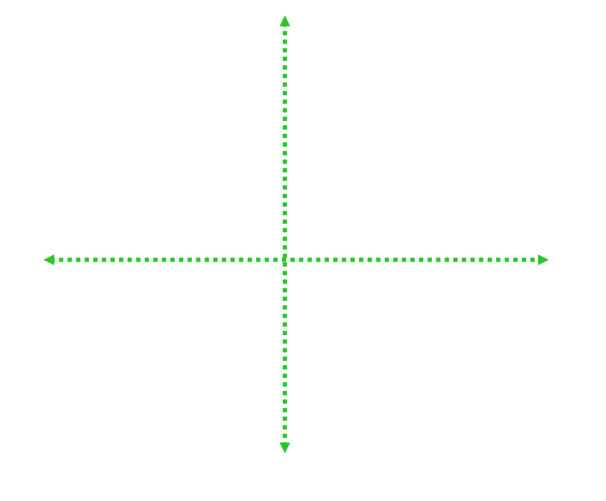

Visually, we can see a point where the derivative (slope of the curve) does not exist (DNE) by looking for "corners" or vertical tangents or "holes" in the graph of the function.
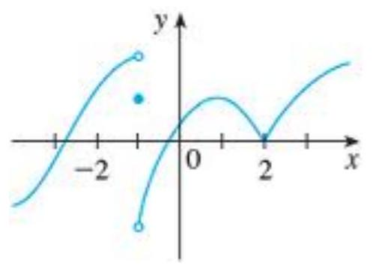

What can we say about the derivative of this function at $x=-1,1$ and 2?

Theorem: Differentiability and continuity
If $f^{'}(x)$ exists, then $f$ is continuous at $x=c$.
Also, if $f(x)$ is discontinuous at $x=c$, then $f^{'}(x)$ does not exist.

EX 5
Discuss the continuity and differentiability of this function at $x=-1,0,1$ :
$$f(x)=\left\{\begin{matrix}\frac{-2}{x} & \text{if} x<-1 \\ |x-1| & \text{if} x≥-1\end{matrix}\right.$$

$$\begin{matrix}\frac{df}{dx} & =\lim_{Δx→0} \frac{f(x+Δx)-f(x)}{Δx} \\ & =\lim_{h→0} \frac{f(x+h)-f(x)}{h} \\ & =\lim_{Δx→0} \frac{Δy}{Δx}\end{matrix}$$

