Math 1220 #1

The Natural Logarithmic Function

The Natural Logarithmic Function
$$D_{x}\left(\frac{x^{3}}{3}\right)=x^{2} \\ D_{x}\left(\frac{x^{2}}{2}\right)=x \\ D_{x}(x)=1 \\ D_{x}(?)=\frac{1}{x} \\ D_{x}\left(\frac{-1}{x}\right)=\frac{1}{x^{2}} \\ D_{x}\left(\frac{-1}{2x^{2}}\right)=\frac{1}{x^{3}}$$

Definition
$$ln⁡x=\int_{1}^{x}{ }\frac{1}{t}dt, x>0$$
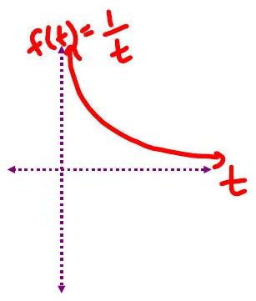

From the First Fundamental Theorem of Calculus
$$D_{x}\left(\int_{1}^{x}{ } \frac{1}{t}dt\right)=D_{x}(ln⁡x)=\frac{1}{x}, x>0$$

EX 1
Find $\frac{dy}{dx}$ if $y=ln⁡\left(x^{2}\right)$

EX 2
Find $\frac{dy}{dx}$ and state the domain

2a)
$y=ln⁡(\sqrt[3]{2x})$

2b)
$y=ln⁡\left(3x^{2}+14x-5\right)$

$$D_{x}[ln⁡|x|]=\frac{1}{x} x≠0$$

Proof

EX 3
Evaluate the integrals.

3a)
$\int{ }\frac{6}{3x-2}dx$

3b)
$\int_{2}^{5}{ }\frac{3x}{7-2x^{2}}dx$ Note: This integral is valid because $7-2x^{2}≠0$ on $[2,5]$

Properties of Logarithms
$$\begin{matrix}ln⁡1=0 & ln⁡(ab)=ln⁡a+ln⁡b \\ ln⁡a^{r}=rln⁡a & ln⁡\left(\frac{a}{b}\right)=ln⁡a-ln⁡b\end{matrix}$$

Proof

EX 4
Rewrite as a single logarithmic expression.
$$ln⁡\left(x^{2}-9\right)-2ln⁡(x-3)-ln⁡(x+3)$$

EX 5
Find $\frac{dy}{dx}$ by logarithmic differentiation $y=\frac{{\left(x^{2}+3\right)}^{\frac{2}{3}}(3x+2)^{2}}{\sqrt{x+1}}$

