Math 1220 #26
The Taylor Approximation to a Function

Taylor Approximations to a Function
Many math problems that occur in applications cannot be solved exactly, like $\int_{0}^{b}{ }sin\left(x^{2}\right)dx$. We need to approximate them.

Taylor Polynomial of order $n$ (based at $a$ )
$$P_{n}(x)=f(a)+f^{'}(a)(x-a)+\frac{f^{''}\left(a\right)}{2!}(x-a)^{2}+…+\frac{f^{\left(n\right)}\left(a\right)}{n!}(x-a)^{n}$$
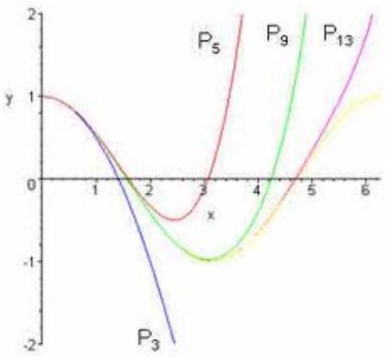

EX 1
For $f\left(x\right)=e^{-3x}$, find the Maclaurin polynomial of order 4 and approximate $f\left(0.12\right)$.

Lagrange Error for Taylor Polynomials
We know $f\left(x\right)=P_{n}\left(x\right)+R_{n}\left(x\right)$.
$$R_{n}\left(x\right)=\frac{f^{\left(n+1\right)}\left(c\right)}{\left(n+1\right)!}{\left(x-a\right)}^{n+1}$$
$c∈\left(a,x\right)$ if $a < x$ or $c∈\left(x,a\right)$ if $x < a$

EX 2
Find the error in estimating $f\left(0.12\right)$ in the last example, $f\left(x\right)=e^{-3x}$.

EX 3
Find a good bound for the maximum value of $\left|\frac{4c}{c+4}\right|$ given $c∈\left[0,1\right]$.

EX 4
Find a good bound for the maximum value of $\left|\frac{c^{2}-c}{cos c}\right|$ given $c∈\left[0,π/4\right]$.

EX 5
Find $n$ such that the Maclaurin polynomial for $f\left(x\right)=e^{x}$ has $f\left(1\right)$ approximated to five decimal places, i.e. $\left|R_{n}\left(1\right)\right|≤0.000005$.

