Math 1220 #27
The Polar Coordinate System

The Polar Coordinate System is a different way to express points in a plane.
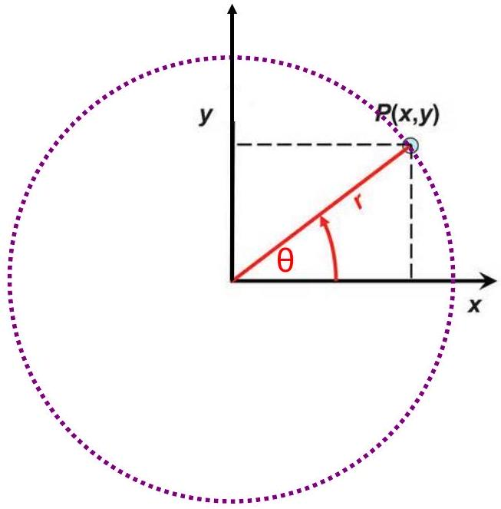

EX 1
Find the rectangular coordinates for this point. (4, π/6)

EX 2
Find the polar coordinates for this point. ( $-2,2$ )

There are an infinite number of ways to write the same point in polar coordinates.
The point $(2,π/4)$ has other names.
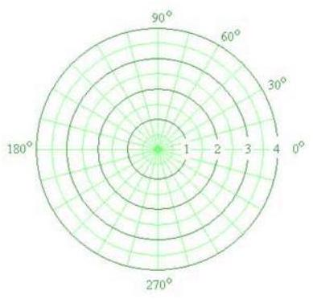

EX 3
Find three other ways to represent the polar coordinates for this point. ( $-3,2π/3$ )

EX 4
Plot $r=6sin⁡θ$.
Prove that it is a circle in the Cartesian Coordinate system.

Polar Equations

1) Lines
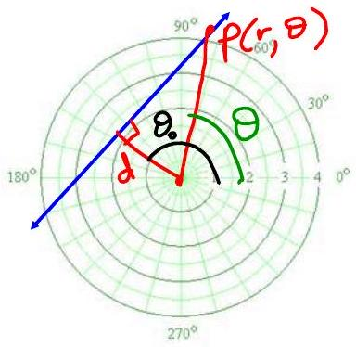

2) Circles
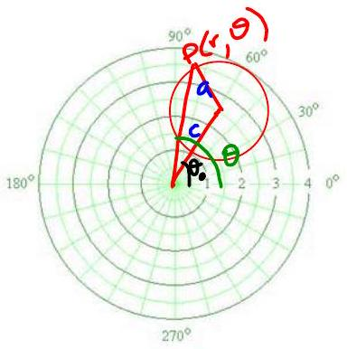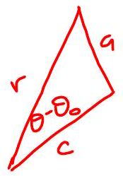

3) Conics (Parabolas, Hyperbolas, Ellipses)
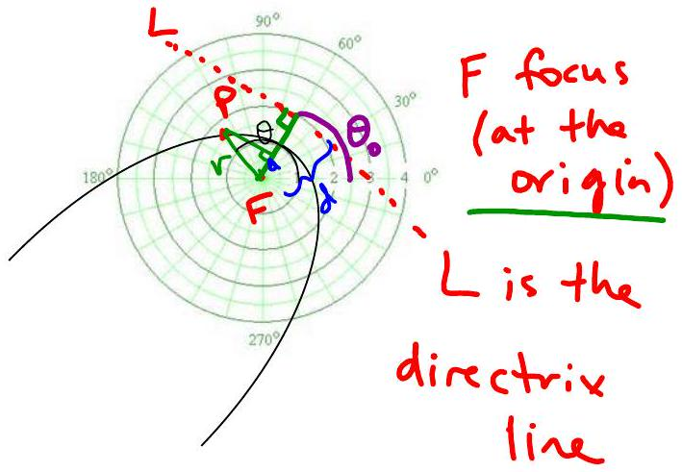

EX 5
Name the curve. If it is a conic, give its eccentricity and sketch it.

5a)
$$r=\frac{2}{2+2cos⁡(θ-π/3)}$$

5b)
$$r=-4cos⁡(θ-π/4)$$

5c)
$$θ=2π/3$$

