Math 1220 #28
Graphs of Polar Equations

Graphs of Polar Equations

Symmetry
About the x-axis ⇒ replacing $(r,θ)$ with $(r,-θ)$ produces equivalent equation
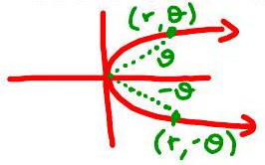
About the y -axis ⇒ replacing $(r,θ)$ with $(-r,-θ)$ produces equivalent equation
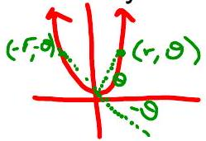

About the origin ⇒ replacing $(r,θ)$ with $(-r,θ)$ produces equivalent equation
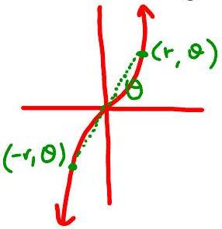

Polar Equations
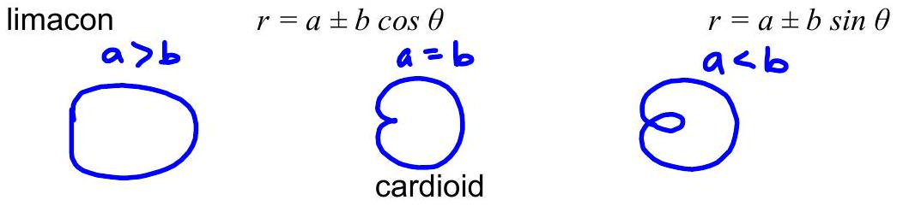
lemniscate
$r^{2}=±a cos(2θ)$ $r^{2}=±a sin(2θ)$

rose
$r=acos⁡(nθ)$ $r=asin⁡(nθ)$

$$n \text{leaves if} n \text{odd}$$
$$2n \text{leaves if} n \text{even}$$

EX 1
Sketch a graph of the given polar equations.

1a)
$$r=4sin⁡θ$$
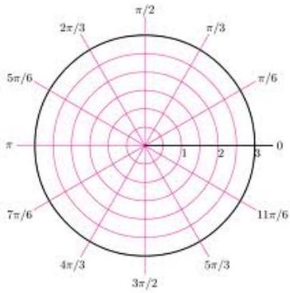

1b)
$$r=-16cos⁡(2θ)$$
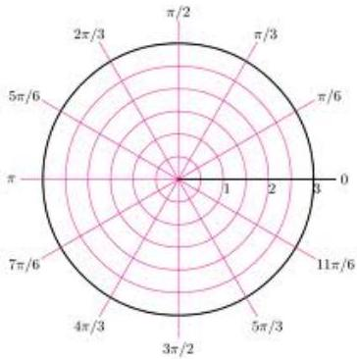

1c)
$$r=4-3sin⁡θ$$
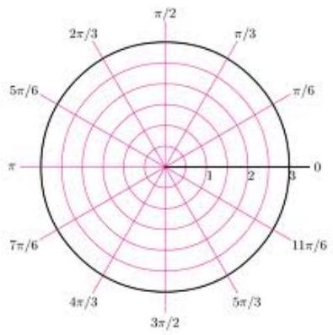

1d)
$$r=2θ$$
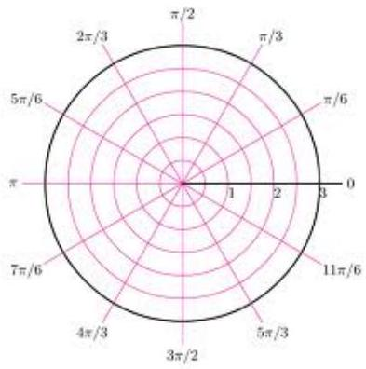

1e)
$$r=\sqrt{2}-\sqrt{2}sin⁡θ$$
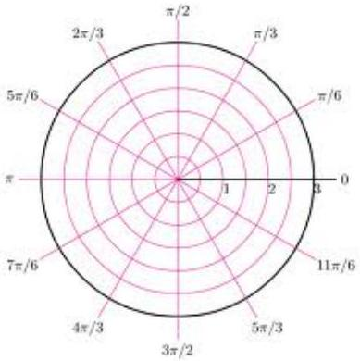

1f)
$$r^{2}=4cos⁡(2θ)$$
