Math 1220 #29
Calculus in Polar Coordinates

Calculus in Polar Coordinates
Begin with the area of a sector of a circle:
$$A=$$
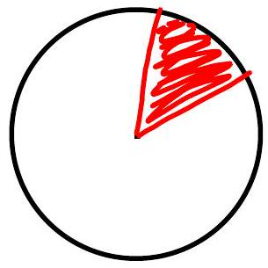
To find area under a curve in the plane
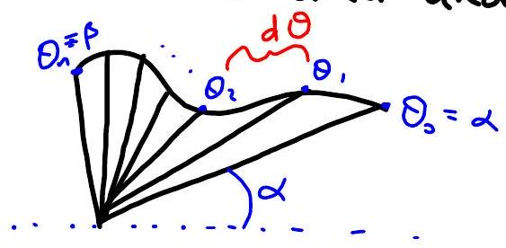 zoom in: 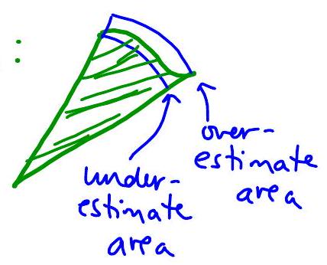

EX 1
Find the area inside $r=3+3sin{θ}$
Cardioid
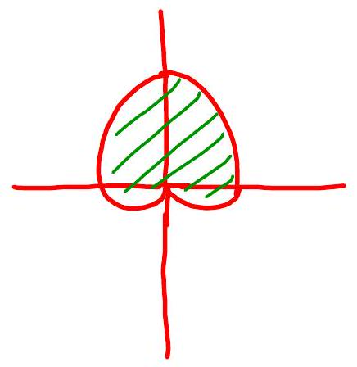

EX 2
Find the area inside $r=3sin{θ}$ (circle) and outside $r=1+sin{θ}$ (cardiod).
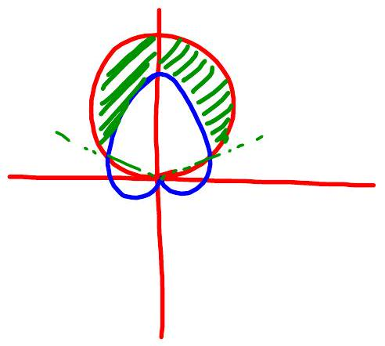

Tangent line slope on a polar curve
$m=\frac{dy}{dx}$ in rectangular coordinates
polar coords $r=f\left(θ\right)$ $⇒$ $\left\{\begin{aligned}y&=r\sin{θ}=f\left(θ\right)\sin{θ} \\ x&=r\cos{θ}=f\left(θ\right)\cos{θ}\end{aligned}\right.$

EX 3
Find the slope of the tangent line to $r=2-3sin{θ}$ at $θ=π/6$.

EX 4
For what values of $θ$ will the tangent line to $r=2-3sin{θ}$ be horizontal?

