Math 1220 #2

Inverse Functions

Inverse Functions
If $f(x)$ and $f^{-1}(x)$ are inverse functions:
- $f(x)$ must be one-to-one,
l.e. The inverse exists when we can get back to an x given a y.
The horizontal line test may be used.
- If (a,b) is on $f(x)$, then (b,a) is on $f^{-1}(x)$.
- $f\left(f^{-1}(x)\right)=f^{-1}(f(x))=x$
- The domain of $f(x)$ becomes the range of $f^{-1}(x)$
- The range of $f(x)$ becomes the domain of $f^{-1}(x)$
Note: $f^{-1}(x)$ is not the reciprocal, $\frac{1}{f^{-1}(x)}$
Let's look at two functions:
$$f(x)=x^{3}$$ | $$f(x)=x^{2}$$
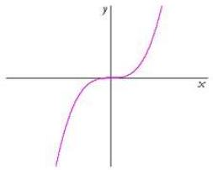 | 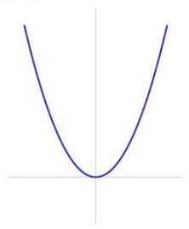

If we don't have a graph, how can we algebraically test if a function has an inverse?

Theorem A
If $f$ is strictly monotonic on its domain, then $f$ has an inverse.

EX 1
Show that this function has an inverse, but do not find it.
$$f(x)=3x^{7}+4x^{3}+x-3$$

EX 2
Explore whether this function has an inverse. If not, can we restrict the domain so it does? If so, find $f^{-1}(x)$.
$$f(x)=x^{2}-4$$

EX 3
Find $f^{-1}(x)$ for this function and check your work.
$$y=\frac{2x-1}{3+5x}$$
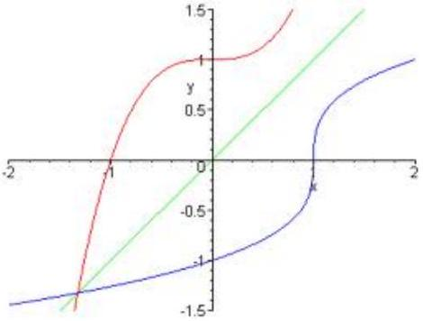

The graph of $f^{-1}(x)$ is $f(x)$ reflected across the line $y=x$.
Notice the slope at ( $d,c$ ) and the slope at $(c,d)$.
$${\left(f^{-1}\right)}^{'}(d)=\frac{1}{f^{'}(c)}$$

Theorem B: Inverse Function Theorem
If $f$ is differentiable, strictly monotonic on an interval and
$f^{'}(x)≠0$ at some $x$ on the interval,
then $f^{-1}(x)$ is differentiable at a corresponding point
in the range of $f$ and ${\left(f^{-1}\right)}^{'}(y)=\frac{1}{f^{'}(x)}$
$$\frac{dx}{dy}=\frac{1}{dy/dx}$$

EX 4
Find ${\left(f^{-1}\right)}^{'}(2)$ using theorem B. $f(x)=x^{5}+5x-4$

