Math 1220 #3

The Natural Exponential Function
The Natural Exponential Function
Remember the graph of $y=ln⁡x$.
It is strictly monotonic, so it has an inverse function.
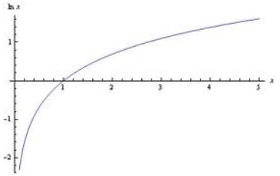

Draw it.
Domain:
Range:
Let's call the inverse function "exp."
$$\begin{matrix} & ln⁡(exp⁡(x))= \\ & exp⁡(ln⁡(x))=\end{matrix}$$

Definition
Let $e$ be a real number such that $ln⁡e=1$.

$$r∈R,exp⁡(r)=exp⁡(rln⁡e) \text{since} ln⁡e=1$$

Theorem
Let a and b be real numbers. Then $e^{a}e^{b}=e^{a+b}$ and $\frac{e^{a}}{e^{b}}=e^{a-b}$

Proof:

How do we take a derivative?
Let $y=e^{x}⇔ln⁡y=x$

EX 1
Find $y^{'}$.

$$y=e^{x^{2}-3x}$$

EX 2
Find $y^{'}$. $y=e^{\sqrt{x}ln⁡x}$

EX 3
For $f(x)$ analyze the graph. (I.e. min, max, concavity, inflection pts, sketch.)
$$f(x)=e^{x}-e^{-x}$$

Since $D_{x}\left[e^{x}\right]=e^{x}$, then $∫e^{x}dx=e^{x}+C$.

EX 4
Evaluate these integrals.

4a)

$∫e^{-6x}dx$

4b)

$∫e^{\left(x+e^{x}\right)}dx$

4c)

$∫\frac{e^{3/x}}{x^{2}}dx$

