Math 1220 #6
Inverse Trigonometry Functions and Their Derivatives

.
The graph of $y=sin⁡x$ does not pass the horizontal line test, so it has no inverse.
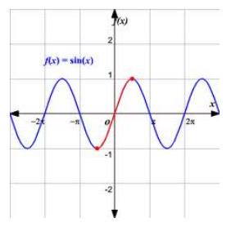

If we restrict the domain (to half a period), then we can talk about an inverse function.
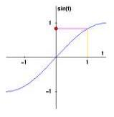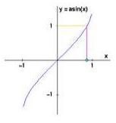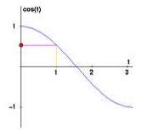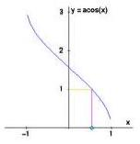

Definition
$$\begin{matrix}x=\sin^{-1}⁡y⇔y=sin⁡x & xϵ\left[-\frac{π}{2},\frac{π}{2}\right] \\ x=\cos^{-1}⁡y⇔y=cos⁡x & xϵ[0,π]\end{matrix}$$

EX 1
Evaluate these without a calculator.

1a)
$\cos^{-1}⁡\left(\frac{\sqrt{3}}{2}\right)$

1b)
$$\sin^{-1}⁡(sin⁡(3π/2))$$

1c)
$$\sin^{-1}⁡(1)$$

1d)
$$\cos^{-1}⁡(cos⁡(-π/4))$$

$$y=tan⁡x$$ | $$y=sec⁡x$$
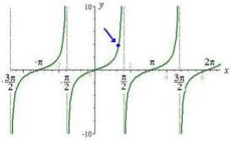 | 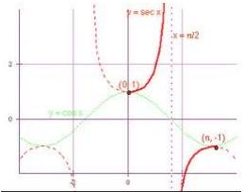

Definition
$$\begin{matrix}x=\tan^{-1}⁡x⇔y=tan⁡x & x∈(-π/2,π/2) \\ x=\sec^{-1}⁡y⇔y=sec⁡x & x∈[0,π/2)∪(π/2,π)\end{matrix}$$

EX 2
Evaluate without a calculator.

2a)
$$\tan^{-1}⁡(-1)$$

2b)
$$\sec^{-1}⁡(2)$$

2c)
$$arctan\left(tan⁡\left(\frac{3π}{4}\right)\right)$$

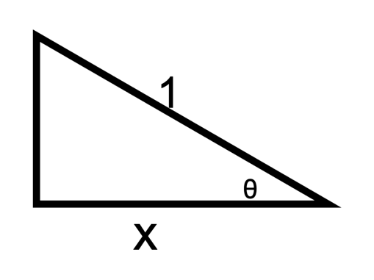
$θ=\cos^{-1}{x}$
$$\sin\left(\cos^{-1}{x}\right)=$$

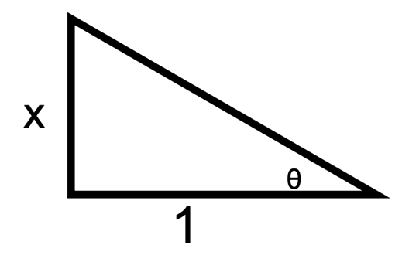
$$θ=tan^{-1}x$$
$$\sec\left(\tan^{-1}{x}\right)=$$

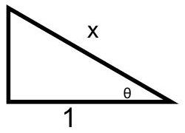
$θ=\sec^{-1}{x}$
$\tan\left(\sec^{-1}{x}\right)$ =

EX 3
Calculate $sin⁡\left[2\cos^{-1}⁡(1/4)\right]$ with no calculator.

Derivatives of Inverse Trig Functions

$$D_{x}\left[sin{x}\right]=\cos{x}$$ | $$D_{x}\left[\cos{x}\right]=-\sin{x}$$
$$D_{x}\left[tan{x}\right]=\sec^{2}{x}$$ | $$D_{x}\left[\cot{x}\right]=-\csc^{2}{x}$$
$$D_{x}\left[\sec{x}\right]=\sec{x}\tan{x}$$ | $$D_{x}\left[\csc{x}\right]=-\csc{x}\cot{x}$$

Let $y=\cos^{-1}⁡x$. Find $y^{'}$.

EX 4
$$D_{x}\left(\tan^{-1}⁡\left(5x^{2}-3x+1\right)\right)=$$

$\left(\begin{matrix}D_{x}\left(\sin^{-1}⁡x\right)=\frac{1}{\sqrt{1-x^{2}}},x_{∈}(-1,1) & D_{x}\left(\cos^{-1}⁡x\right)=\frac{-1}{\sqrt{1=x^{2}}} \\ D_{x}\left(\sec^{-1}⁡x\right)=\frac{1}{|x|\sqrt{x^{2}-1}},|x|>1 & D_{x}\left(\tan^{-1}⁡x\right)=\frac{1}{1+x^{2}}\end{matrix}\right)$

EX 5
Evaluate these integrals.
$$\begin{matrix}\int{ }\frac{1}{\sqrt{1-x^{2}}}dx=\sin^{-1}⁡x+C \\ \int{ }\frac{1}{1+x^{2}}dx=\tan^{-1}⁡x+C \\ \int{ }\frac{1}{x\sqrt{x^{2}-1}}dx=\sec^{-1}⁡|x|+C\end{matrix}$$

5a)
$$\int_{-1}^{1}{ }\frac{1}{1+x^{2}}dx$$

5b)
$$\int{ }\frac{e^{x}}{1+e^{2x}}dx$$

