Math 1220 #7
The Hyperbolic Functions

Hyperbolic Functions
$$\begin{matrix} & sinh⁡x=\frac{e^{x}-e^{-x}}{2} ( \text{culled "Sinsh")} \\ & cosh⁡x=\frac{e^{x}+e^{-x}}{2} \\ & tanh⁡x=\frac{sinh⁡x}{cosh⁡x}\end{matrix}$$

Relation to the trigonometric functions

- $(cos⁡θ,sin⁡θ)$ is a point on the unit circle.  - $y=sin⁡x$ is an odd function.  - $y=cos⁡x$ is an even function.  - $\sin^{2}⁡θ+\cos^{2}⁡θ=1$  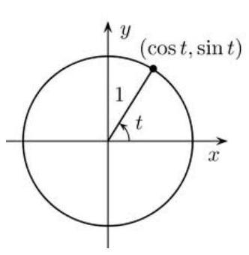 | - $(cosh⁡θ,sinh⁡θ)$ is a point on the unit hyperbola.  - $y=sinh⁡x$ is an odd function.  - $y=cosh⁡x$ is an even function.  - $\cosh^{2}{θ}-\sinh^{2}{θ}=1$  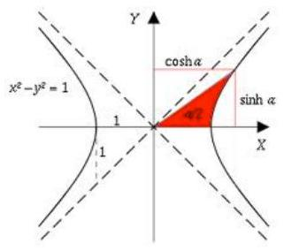

Prove $\cosh^{2}⁡θ-\sinh^{2}⁡θ=1$.

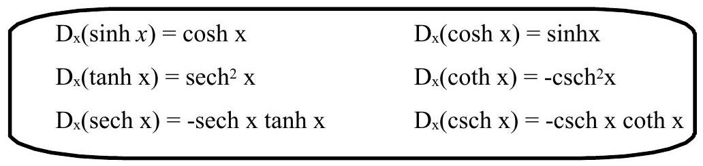

EX 1
$$D_{x}\left(\coth\left(4x\right)\sinh{x}\right)=$$

EX 2
$$\int{\tanh{x}}\ln\left(\cosh{x}\right)dx=$$

EX 3
Verify this identity.
$$tanh⁡(x-y)=\frac{tanh⁡x-tanh⁡y}{1-tanh⁡xtanh⁡y} \text{Hint:} tanh⁡x=\frac{e^{x}-e^{-x}}{e^{x}+e^{-x}}$$

Inverse Hyperbolic Functions
Let $y=sinh⁡x⇔x=\sinh^{-1}⁡y$ (if the inverse exists).
Find $x=\sinh^{-1}⁡y$.

$$\begin{matrix}\sinh^{-1}⁡x=ln⁡\left(x+\sqrt{x^{2}+1}\right) & \cosh^{-1}⁡x=ln⁡\left(x+\sqrt{x^{2}-1}\right) x≥1 \\ \tanh^{-1}⁡x=\frac{1}{2}ln⁡\left(\frac{1+x}{1-x}\right) x∈(-1,1) & sechh^{-1}x=ln⁡\left(\frac{1+\sqrt{1-x^{2}}}{x}\right) x∈(0,1]\end{matrix}$$

How do we find the derivative of these functions?
$$D_{x}\left(\sinh^{-1}⁡x\right)=D_{x}\left(ln⁡\left(x+\sqrt{x^{2}+1}\right)\right)$$

$$\frac{d}{dx}\left(\sinh^{-1}{x}\right)=\frac{1}{\sqrt{x^{2}+1}}$$

$$\frac{d}{dx}\left(\cosh^{-1}{x}\right)=\frac{1}{\sqrt{x^{2}-1}}, x>1$$

$$\frac{d}{dx}\left(\tanh^{-1}{x}\right)=\frac{1}{1-x^{2}}, x∈\left(-1,1\right)$$

$$\frac{d}{dx}\left({sech}^{-1}{x}\right)=-\frac{1}{x\sqrt{1-x^{2}}}, x∈\left(0,1\right)$$

EX 4
Find $y^{'}$.
$$y=x^{2}\sinh^{-1}⁡\left(x^{5}\right)$$

