Math 2210 #10
Functions of Two or More Variables
A real-valued function of 2 variables takes two real input values and returns one real output value.
e.g. $f\left(x,y\right)=x^{2}+3y^{2}$ or $g\left(x,y\right)=\sqrt{xy}+2x^{3}$.
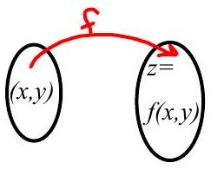
independent variables ⇒
dependent variable ⇒
domain ⇒
range ⇒

EX 1
$f\left(x,y\right)=\frac{y}{x}+xy$, find

1a)
$$f\left(1,2\right)$$

1b)
$$f\left(a,a\right)$$

1c)
$f\left(\frac{1}{x},x^{2}\right)$

1d)
What is the domain of $f$ ?
The graph of a function of 2 variables is a 3D surface (usually). Since it is a function, then to each output, $z$, there can only be one $\left(x,y\right)$ from the domain. Graphically, this means that each line perpendicular to the $xy$-plane intersects the surface in at most one point.

EX 2
Sketch the graph of $f\left(x,y\right)=6-x^{2}$.
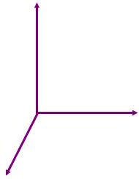

EX 3
Sketch the graph of $f\left(x,y\right)=\sqrt{16-4x^{2}-y^{2}}$.
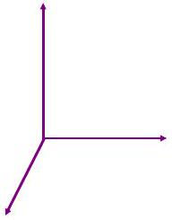
Level Curves ⇒ Projection of intersecting curves (with surface and planes $z=c,c$ is real) onto the $xy$-plane.
Contour Map ⇒ a collection of level curves.

EX 4
Sketch level curves at $z=-1,0,1,4,9$ for $z=1/4x^{2}+y^{2}$.
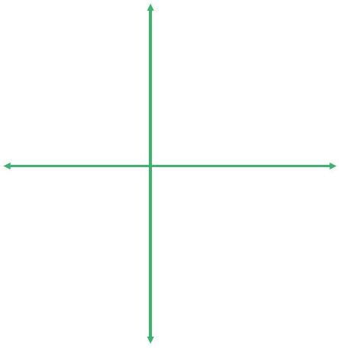

EX 5
Sketch level curves at $z=-4,-1,0,1,4$ for $z=y^{2}-x^{2}$.
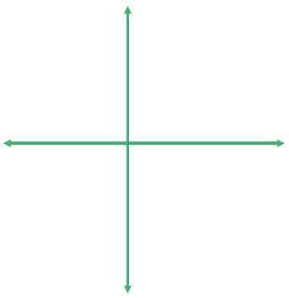

EX 6
Find the domain for $f\left(x,y,z\right)=\sqrt{x^{2}+y^{2}-z^{2}-9}$.

