Math 2210 #11
Partial Derivatives

Partial Derivatives
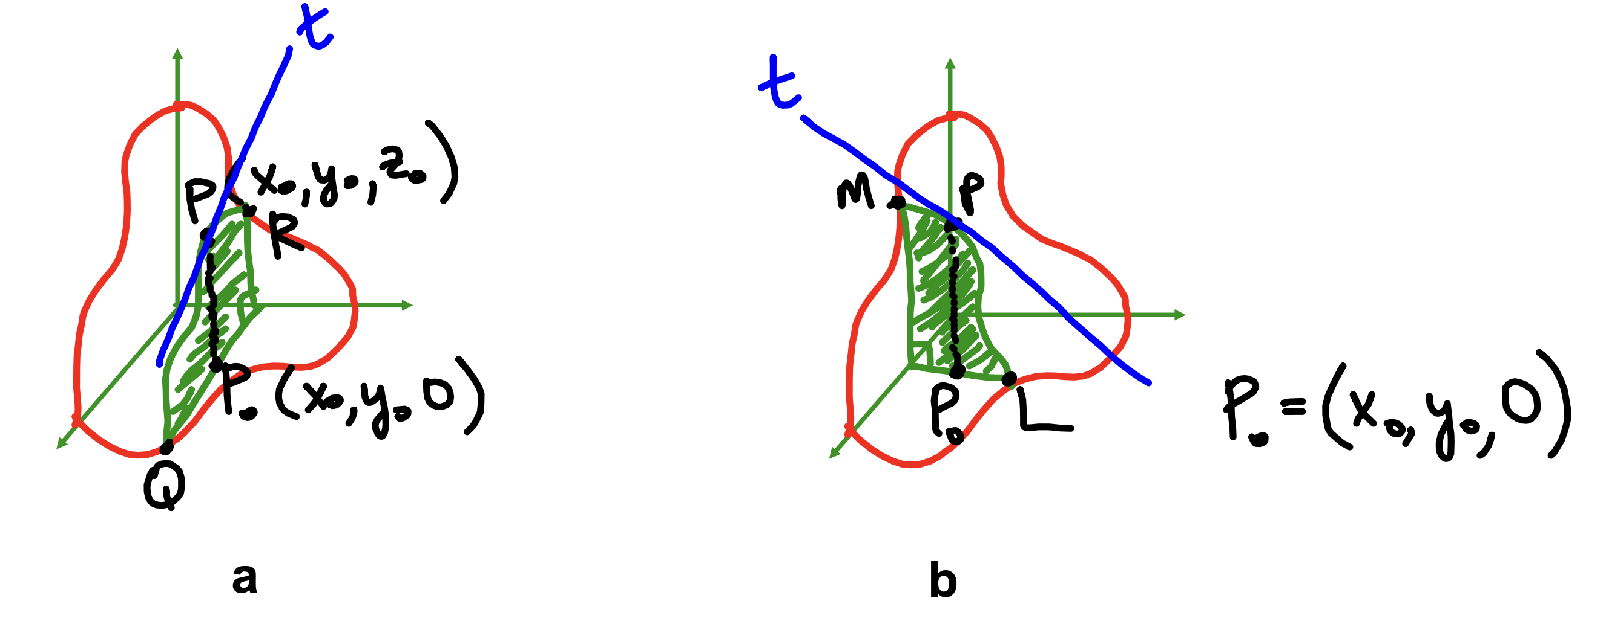
Consider the same surface cut by two different planes.
In a it is cut by $y=y_{0}$,
in $b$ it is cut by $x=x_{0}$.
The curve of intersection in a goes through plane RPQ and in b through plane MPL.
Each of those curves has a tangent line associated with it at point P.
Each tangent line has a steepness associated with it and that should make us think about what?

Since our function is now a function of two variables (rather than one), we can only take the partial derivative with respect to one of the variables.
$$\begin{matrix}f_{x}\left(x_{0},y_{0}\right) & =\lim_{Δx→0} \frac{f\left(x_{0}+Δx,y_{0}\right)-f\left(x_{0},y_{0}\right)}{Δx} \\ f_{y}\left(x_{0},y_{0}\right) & =\lim_{Δy→0} \frac{f\left(x_{0},y_{0}+Δy\right)-f\left(x_{0},y_{0}\right)}{Δy}\end{matrix}$$

EX 1
Find $f_{x}(0,3)$ and $f_{y}(0,3)$ if $f(x,y)=3x^{2}y^{2}+4y^{3}-5$.

Notation
If $z=f(x,y)$, then
$$\begin{matrix}f_{x}(x,y)=\frac{∂z}{∂x}=\frac{∂f(x,y)}{∂x} partial derivative of f with respect to x \\ f_{y}(x,y)=\frac{∂z}{∂y}=\frac{∂f(x,y)}{∂y} partial derivative of f with respect to y \\ \end{matrix}$$

EX 2
$$\begin{matrix}If z=x^{2}y+cos⁡(xy)-2, find \frac{∂z}{∂x} and \frac{∂z}{∂y}\end{matrix}$$

EX 3
Find the 'slope' of the tangent line to the curve of intersection of this surface
$$3z=\sqrt{36-9x^{2}-4y^{2}}$$and the plane $x=1$
at the point $(1,-2,\sqrt{11}/3)$.
The 'slope' here refers to the change in $z$ over the change in $y$.

EX 4
The temperature in degrees celsius on a metal plate in the $xy$-plane is given by
$T(x,y)=4+2x^{2}+y^{3}$. What is the rate of change of temperature with respect to distance (in feet) if we start moving from $(3,2)$ in the direction of the y -axis?

Higher Order Partial Derivatives

$$\begin{matrix}f_{xx}=\frac{∂}{∂x}\left(\frac{∂f}{∂x}\right)=\frac{∂^{2}f}{∂x^{2}} & f_{yy}=\frac{∂}{∂y}\left(\frac{∂f}{∂y}\right)=\frac{∂^{2}f}{∂y^{2}} \\ f_{xy}={\left(f_{x}\right)}_{y}=\frac{∂}{∂y}\left(\frac{∂f}{∂x}\right)=\frac{∂^{2}f}{∂y∂x} & f_{yx}={\left(f_{y}\right)}_{x}=\frac{∂}{∂x}\left(\frac{∂f}{∂y}\right)=\frac{∂^{2}f}{∂x∂y}\end{matrix}$$

EX 5
Find all four second partial derivatives for $f(x,y)={\left(x^{3}+y^{2}\right)}^{5}$.

EX 6
Find all four second partial derivatives for $f(x,y)=\tan^{-1}⁡(xy)$.

EX 7
For $f(x,y,z)=xy^{2}-\frac{2x}{yz}+3z^{3}x$, find $f_{x},f_{y},f_{z},f_{xz}$ and $f_{yy}$.

