Math 2210 #12
Limits and Continuity

Review from Calculus 1

Definition: Continuity at a Point
Let $f$ be defined on an open interval containing $c$. We say that $f$ is continuous at $c$ if
$$\lim_{x→c} f(x)=f(c)$$
This indicates three things:
- The function is defined at $x=c$.
- The limit exists at $x=c$.
- The limit at $x=c$ needs to be exactly the value of the function at $x=c$.
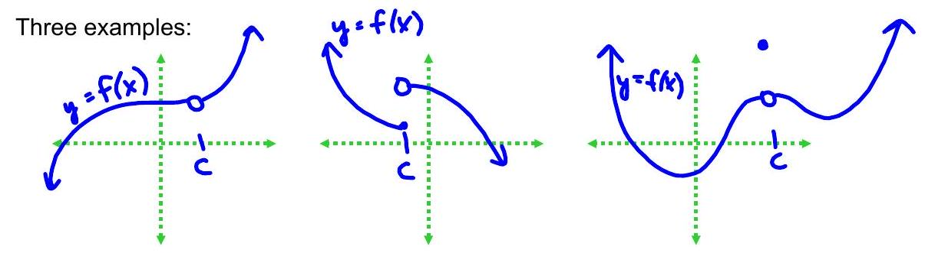

Limits and Continuity
Intuitively, $\lim_{(x,y)→(a,b)} f(x,y)=L$ means that as the point $(x,y)$ gets very close to ( $a,b$ ), then $f(x,y)$ gets very close to $L$. When we did this for functions of one variable, it could approach from only two sides or directions (left or right). Now we can approach $(a,b)$ from infinitely many directions.
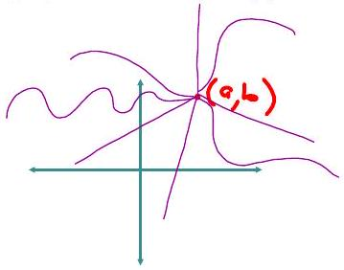

Definition of Limit
$\lim_{(x,y)→(a,b)} f(x,y)=L$ means that for all $ε>0$ there exists a corresponding $δ>0$ such that $|f(x,y)-L|<ε$ provided that $0<|(x,y)-(a,b)|<δ$. We can make $f(x,y)$ as close as we'd like to $L$ by choosing $(x,y)$ sufficiently close to ( $a,b$ ).
$$|(x,y)-(a,b)|=\sqrt{(x-a)^{2}+(y-b)^{2}}$$

EX 1
Find $\lim_{(x,y)→(-2,1)} \left(xy^{3}-xy+3y^{2}\right)$.

EX 2
Find
$$\lim_{(x,y)→(0,0)} \frac{1+xy}{cos⁡(xy)}$$

EX 3
$$\lim_{(x,y)→(0,0)} \frac{tan⁡\left(x^{2}+y^{2}\right)}{x^{2}+y^{2}}$$

EX 4
Show that $\lim_{(x,y)→(0,0)} \frac{xy+y^{3}}{x^{2}+y^{2}}$ does not exist.

EX 5
Find the limits.

5a)
$\lim_{(x,y)→(0,0)} \frac{x^{3}}{x^{2}+y^{2}}$ Hint: Use polar coordinates.

5b)
$$\lim_{(x,y)→(0,0)} \frac{x}{x^{2}+y^{2}}$$

5c)
$$\lim_{(x,y)→(0,0)} \frac{x^{2}}{x^{2}+y^{2}}$$

Continuity
A function $f(x,y)$ is continuous at $(a,b)$ if $f(a,b)=\lim_{(x,y)→(a,b)} f(x,y)$
This indicates three things:
- the function is defined at ( $a,b$ ),
- the limit of $f$ as $(x,y)→(a,b)$ exists, and
- the limit of $f$ at ( $a,b$ ) is exactly the same as $f(a,b)$.
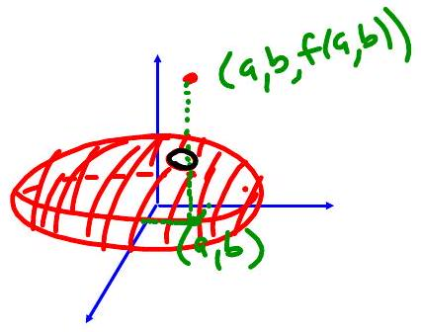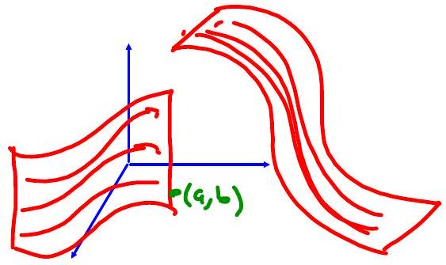

Composition of Functions
If a function, $g$, of two variables is continuous at ( $a,b$ ) and a function, $f$, of one variable is continuous at $g(a,b)$, then
$(f∘g)(x,y)=f(g(x,y))$ is continuous at $(a,b)$.

EX 6
Show that $f(x,y)=sin⁡\left(x^{2}-4xy\right)$ is continuous everywhere.

EX 7
Determine where $f(x,y)=ln⁡\left(1-x^{2}-y^{2}\right)$ is continuous.

EX 8
Is $f(x,y)=\left\{\begin{matrix}\frac{sin⁡(xy)}{xy} & \text{if} xy≠0 \\ 1 & \text{if} xy=0\end{matrix}\right.$ continuous everywhere?

