Math 2210 #13
Differentiability/Gradient

Differentiability
For a function of one variable, the derivative gives us the slope of the tangent line, and a function of one variable is differentiable if the derivative exists. For a function of two variables, the function is differentiable at a point if it has a tangent plane at that point. But existence of the first partial derivatives is not quite enough, unlike the one-variable case.

Theorem
If $f(x,y)$ has continuous partial derivatives $f_{x}(x,y)$ and $f_{y}(x,y)$ on a disk D whose interior contains $(a,b)$, then $f(x,y)$ is differentiable at $(a,b)$.

Theorem
If $f$ is differentiable at ( $a,b$ ), then $f$ is continuous at ( $a,b$ ).

Gradient of $f$
$$∇f(p)=∇f(a,b)=\left\langle f_{x}(a,b),f_{y}(a,b)\right\rangle =f_{x}(a,b)\overset{ˆ}{i}+f_{y}(a,b)\overset{ˆ}{j}$$
for a function, $z=f(x,y)$.
(Note: This gradient lives in 2-D space, but it is the gradient of a function whose graph is 3-D.)

Properties of Gradient Operator
$p$ is the input point ( $a,b$ ).
$$\begin{matrix} & ∇[f(p)+g(p)]=∇f(p)+∇g(p) \\ & ∇[αf(p)]=α∇f(p),α∈R \\ & ∇[f(p)g(p)]=f(p)∇g(p)+∇f(p)g(p)\end{matrix}$$

EX 1
Find the gradient of $f$.

1a)
$f(x,y)=x^{3}y-y^{3}$

1b)
$f(x,y)=\sin^{3}⁡\left(x^{2}y\right)$

1c)
$f(x,y,z)=xzln⁡(x+y+z)$

Curves in 2-D | Surfaces in 3-D
Remember the equation of the tangent line to a 2-D curve. | 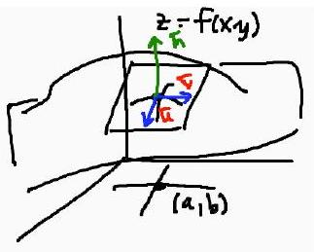

EX 2
For $f(x,y)=x^{3}y+3xy^{2}$, find the equation of the tangent plane at $(a,b)=(2,-2)$.

EX 3
Find the equation of the tangent "hyperplane" to $f(x,y,z)$ at the point $(a,b,c)$.
$$f(x,y,z)=xyz+x^{2} (a,b,c)=(2,0,-3)$$

EX 4
Find all domain points $(x,y)$ at which the tangent plane to the graph of $z=x^{3}$ is horizontal.

