Math 2210 #14
Directional Derivatives

Directional Derivatives
We know we can write
$$\frac{∂f}{∂x}=f_{x}(a,b)=\lim_{h→0} \frac{f(a+h,b)-f(a,b)}{h}$$

$$\frac{∂f}{∂y}=f_{y}(a,b)=\lim_{h→0} \frac{f(a,b+h)-f(a,b)}{h}$$
The partial derivatives measure the rate of change of the function at a point in the direction of the $x$-axis or $y$-axis. What about the rates of change in the other directions?

Definition
For any unit vector, $\overset{ˆ}{u}=\left\langle u_{x},u_{y}\right\rangle$ let
$$D_{\overset{˜}{u}}f(a,b)=\lim_{h→0} \frac{f\left(a+hu_{x},b+hu_{y}\right)-f(a,b)}{h}$$
If this limit exists, this is called the directional derivative of $f$ at the point ( $a,b$ ) in the direction of $\overset{ˆ}{u}$.

Theorem
Let $f$ be differentiable at the point $(a,b)$. Then $f$ has a directional derivative at ( $a,b$ ) in the direction of $\overset{ˆ}{u}.\overset{ˆ}{u}=u_{x}\overset{ˆ}{i}+u_{y}\overset{ˆ}{j}$ and $D_{\overset{‾}{u}}f(a,b)=\overset{ˆ}{u}⋅∇f(a,b)$.

EX 1
Find the directional derivative of $f(x,y)$ at the point $(a,b)$ in the direction of $\vec{u}$. (Note: $\vec{u}$ may not be a unit vector.)

1a)
$f\left(x,y\right)=y^{2}\ln\left(x\right)$ $\left(a,b\right)=\left(1,4\right)$ $\vec{u}=\hat{i}-\hat{j}$

1b)
$f\left(x,y\right)=2x^{2}sin⁡y+xy$ $\left(a,b\right)=(1,π/2)$ $\vec{u}=2\overset{ˆ}{ı}+\overset{ˆ}{j}$

Maximum Rate of Change
We know $D_{\overset{ˆ}{u}}f(a,b)=\overset{ˆ}{u}⋅∇f(a,b)$
$$=‖\overset{ˆ}{u}‖‖∇f(a,b)‖cos⁡θ$$
What angle, $θ$, maximizes $D_{uf}f(a,b)$ ?

Theorem
The function, $z=f(x,y)$, increases most rapidly at ($a,b$) in the direction of the gradient (with rate $‖∇f(a,b)‖$) and decreases most rapidly in the opposite direction (with rate $-‖∇f(a,b)‖$ ).

EX 2
For $z=f(x,y)=x^{2}+y^{2}$, interpret gradient vector.

EX 3
Find a vector indicating the direction of most rapid increase of $f(x,y)$ at the given point. Then find the rate of change in that direction.

3a)
$f(x,y)=e^{y}sin⁡x$ at $(a,b)=(5π/6,0)$

3b)
$f(x,y)=x^{2}y-2/(xy)$ at $(a,b)=(1,1)$

EX 4
The temperature at $(x,y,z)$ of a ball centered at the origin is $T=100e^{-\left(x^{2}+y^{2}+z^{2}\right)}$.
Show that the direction of greatest decrease in temperature is always a vector pointing away from the origin.

One extra (cool) fact

Theorem
The gradient of $z=f(x,y)(w=f(x,y,z))$ at point $P$ is perpendicular to the level curve (surface) of $f$ through $P$.
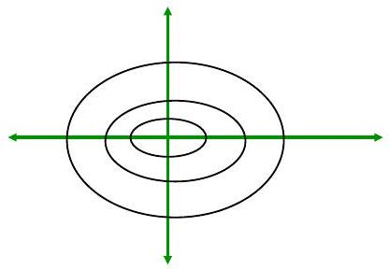

EX 5
Graph gradient vectors and level curves for
$$z=f(x,y)=\frac{x^{2}}{9}+\frac{y^{2}}{25}.$$

