Math 2210 #19
Double Integrals Over Rectangles, Iterated Integrals

EX 1
If $f\left(x,y\right)=\left\{\begin{matrix}-1 & 1≤x≤4, & 0≤y<1 \\ 2 & 1≤x≤4, & 1≤y≤2\end{matrix}\right.$
find the signed volume between the $z=f\left(x,y\right)$ surface and the $xy$-plane.

Definition (Double Integral)
Let $z=f\left(x,y\right)$ be defined on a closed rectangle, $R$.
If $\lim_{\left|p\right|→0} \sum_{k=1}^{n}{ }f\left({\overset{‾}{x}}_{k},{\overset{‾}{y}}_{k}\right)ΔA_{k}$ exists, then $f$ is integrable over $R$ and the double integral
$$\iint_{R}{ }f\left(x,y\right)dA=\lim_{\left|p\right|→0} \sum_{k=1}^{n}{ }f\left({\overset{‾}{x}}_{k},{\overset{‾}{y}}_{k}\right)ΔA_{k}$$
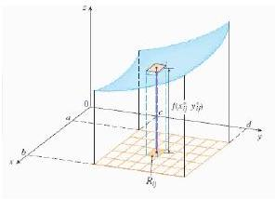

Integrability Theorem
If $f$ is continuous on the closed rectangle $R$, then $f$ is integrable on $R$.

EX 2
Let $R=\left(x,y\right)∣0≤x≤6,0≤y≤4$ and $f\left(x,y\right)=16-y^{2}$. Partition $R$ into 6 equal squares by lines $x=2,x=4$ and $y=2$. Approximate $\iint_{R}{ }f\left(x,y\right)dA$ as $\sum_{k=1}^{6}{ }f\left({\overset{‾}{x}}_{k},{\overset{‾}{y}}_{k}\right)ΔA_{k}$
where ( ${\overset{‾}{x}}_{k},{\overset{‾}{y}}_{k}$ ) are centers of squares.

Iterated Integrals
The total volume is the sum of many rectangular boxes and then we take the limit as the number of boxes goes to infinity to get the exact volume.
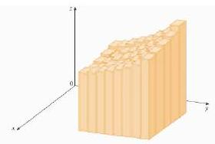
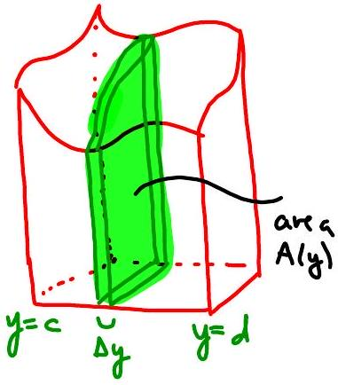

To find this volume, we can take thin "slab" cross-sections and add them up. Each slab has volume $A\left(y\right)Δy$.
$$\begin{matrix} & V=\int_{c}^{d}{ } A\left(y\right)dy \\ & A\left(y\right)=\int_{a}^{b}{ } f\left(x,y\right)dx\end{matrix}$$

Properties of the Double Integral
- It is a linear operator
  - $\iint_{R}{ }kf\left(x,y\right)dA=k\iint_{R}{ }f\left(x,y\right)dA$ and
  - $\iint_{R}{ }\left[f\left(x,y\right)+g\left(x,\overset{R}{y}\right)\right]dA=\iint_{R}{ }f\left(x,\overset{R}{y}\right)dA+\iint_{R}{ }g\left(x,y\right)dA$
- Additive on rectangles $\iint_{R}{ }f\left(x,y\right)dA=\iint_{R_{1}}{ }f\left(x,y\right)dA+\iint_{R_{2}}{ }f\left(x,y\right)dA$
where $R_{1}$ and $R_{2}$ overlap only on a line segment and comprise all of $R$
- If $f\left(x,y\right)≤g\left(x,y\right)$, then $\iint_{R}{ }f\left(x,y\right)dA≤\iint_{R}{ }g\left(x,y\right)dA$
- $\iint_{R}{ }kdA=k\iint_{R}{ }dA=kA\left(R\right)$

EX 3
Calculate $\iint_{R}{ }f\left(x,y\right)dA$ where $f\left(x,y\right)=7-y$
$$R=\left(x,y\right)∣0≤x≤2,0≤y≤1$$
Hint: Sketch it and see if you recognize it.

Let's practice computing some double integrals.

EX 4
Evaluate $\int_{0}^{4}{ }\left[\int_{-1}^{2}{ } \left(x^{2}-3y\right)dx\right]dy$

EX 5
$$\int_{0}^{1}{ }\int_{0}^{1}{ }\frac{y}{{\left(xy+1\right)}^{2}}dxdy$$

EX 6
$$\iint_{R}{ }xy\sqrt{1+x^{2}}dAR=\left(x,y\right)∣0≤x≤\sqrt{3},1≤y≤2$$

EX 7
Find the volume of the solid in the first octant enclosed by $z=4-x^{2}$ and $y=2$.

