Math 2210 #1
Parametric Representations of Plane Curves
A plane curve is a 2 -dimensional curve given by
$$x=f(t) y=g(t) t∈I$$
where $f$ and $g$ are continuous functions on the interval $I,[a,b]$. $t$ is the parameter. $t∈[a,b]$
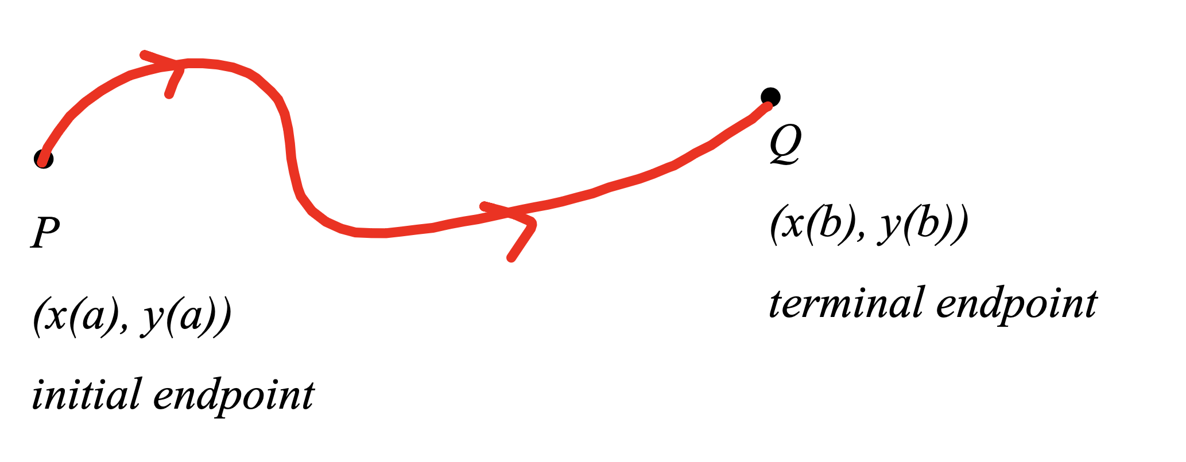
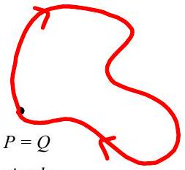 | 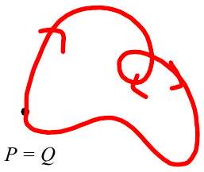 | 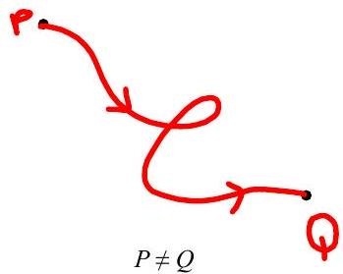
simple, closed curve | not simple, closed curve | not simple, not closed curve

It can be hard to recognize the shape of a curve when given parametically. Sometimes it is possible to eliminate the parameter.

EX 1
Eliminate the parameter and sketch this curve.
$$x=t-3 y=\sqrt{t} 0≤t≤8$$
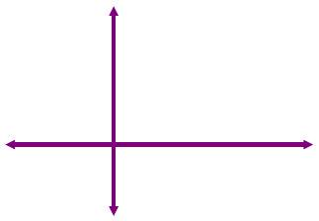

EX 2
Eliminate the parameter $t$, graph the curve and tell if it is simple and closed.
$$x=\sqrt{t-3} y=\sqrt{4-t} 3≤t≤4$$

EX 3
Eliminate the parameter $θ$, graph the curve and tell if it is simple and closed.
$$x=sin⁡θ y=2\cos^{2}⁡(2θ) θ∈R$$
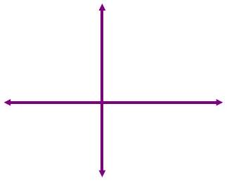

Theorem A
Let $f$ and $g$ be continuously differentiable with $f^{'}(t)≠0$ on $t∈(α,β)$.
Then the parametric equations $x=f(t)$ and $y=g(t)$ define $y$ as a differentiable function of $x$ and
$$\frac{dy}{dx}=\frac{dy/dt}{dx/dt} \frac{d^{2}y}{dx^{2}}=\frac{dy^{'}/dt}{dx/dt} \text{where} y^{'}=\frac{dy}{dx}$$

EX 4
Find $\frac{dy}{dx}$ and $\frac{d^{2}y}{dx^{2}}$ (without eliminating the parameter.)

4a)
$$x=\sqrt{3}θ^{2} y=-\sqrt{3}θ^{3} θ≠0$$

4b)
$$x=\frac{2}{1+t^{2}} y=\frac{2}{t\left(1+t^{2}\right)} t≠0$$

$$\text{Length of a curve:} L=\int_{a}^{b}{ }\sqrt{{\left(\frac{dx}{dt}\right)}^{2}+{\left(\frac{dy}{dt}\right)}^{2}}dt$$

EX 5
Find the length of the curve given by
$$\begin{matrix} & x=sin⁡θ-θcos⁡θ θ∈[π/4,π/2] \\ & y=cos⁡θ+θsin⁡θ\end{matrix}$$

