Math 2210 #20
Double Integrals Over Non-rectangular Regions

Double Integrals over Non-rectangular Regions
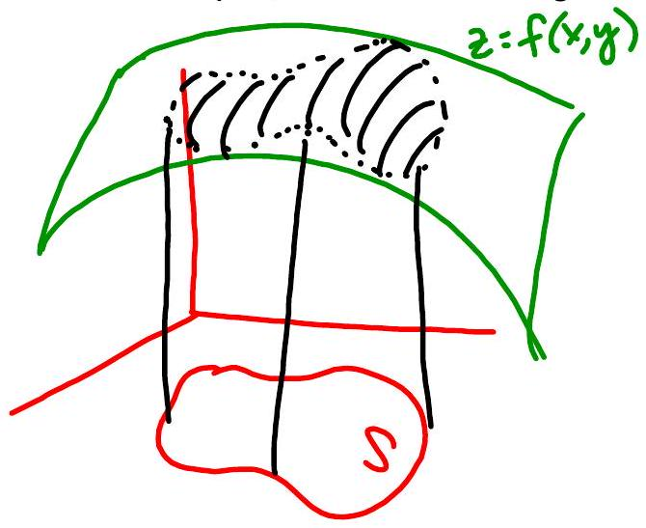
What if the region we're integrating over is not a rectangle, but a simple, closed curve region instead?
$$\begin{matrix} & V=\iint_{S}{ } f(x,y)dA \\ & =\int_{a}^{b}{ } \int_{ϕ_{1}(x)}^{ϕ_{2}(x)}{ } f(x,y)dydx \\ & =\int_{c}^{d}{ } \int_{h_{1}(y)}^{h_{2}(y)}{ } f(x,y)dxdy\end{matrix}$$

EX 1
Find $\iint_{S}{ }5dA$ where $S$ is the triangle with vertices at $(0,0),(0,4)$, and $(1,4)$.
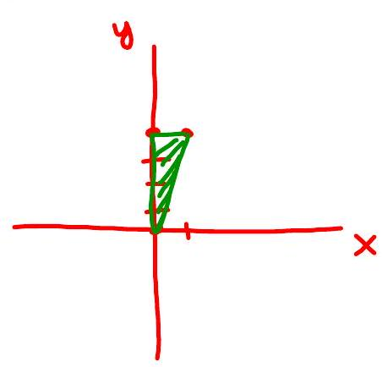

EX 2
Evaluate $\iint_{S}{ }xdA$ where $S$ is the region between $y=x$ and $y=x^{2}$ in the first octant.

EX 3
Write these integrals as iterated integrals with the order of integration switched.

3a)
$$\int_{0}^{2}{ }\int_{y^{2}}^{2y}{ }f(x,y)dxdy$$
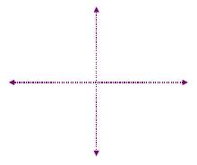

3b)
$$\int_{1/2}^{1}{ }\int_{x^{3}}^{x}{ }f(x,y)dydx$$
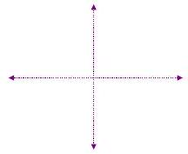

3c)
$$\int_{0}^{1}{ }\int_{-y}^{y}{ }f(x,y)dxdy$$
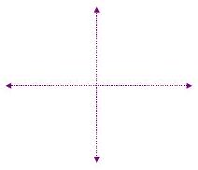

EX 4
Evaluate

4a)
$$\int_{1}^{5}{ }\int_{0}^{x}{ }\frac{3}{x^{2}+y^{2}}dydx$$

4b)
$$\int_{π/6}^{π/2}{ }\int_{0}^{sin⁡θ}{ }6rcos⁡θdrdθ$$

EX 5
Find the volume of the solid bounded by the parabolic cylinder $x^{2}=4y$ and the planes $z=0$ and $5y+9z-45=0$.

