Math 2210 #21
Double Integrals in Polar Coordinates

Double Integrals in Polar Coordinates
Rather than finding the volume over a rectangle (for Cartesian Coordinates), we will use a "polar rectangle" for polar coordinates.
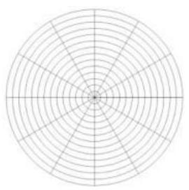
$$A_{sector}=πr^{2}\frac{Δθ}{2π}=\frac{1}{2}Δθr^{2}$$
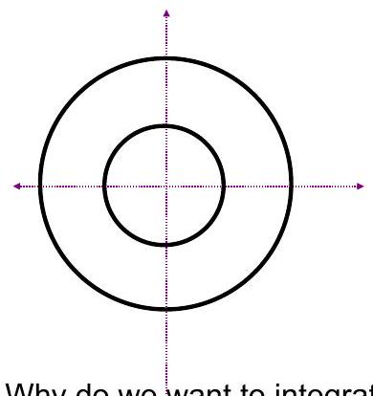

Area of a polar rectangle
Why do we want to integrate polar coordinates?

EX 1
Find the area of the given region $S$ by calculating
$$A=\iint_{S}{ }dA=\iint_{S}{ }rdrdθ$$

1a)
$S$ is the smaller region bounded by $θ=π/6$ and $r=4sin⁡θ$.

EX 1
(cont'd) Find the area of the given region $S$ by calculating
$$\iint_{S}{ }rdrdθ$$

1b)
$S$ is the region outside the circle $r=2$ and inside the lemniscate $r^{2}=9cos⁡(2θ)$.

EX 2
Evaluate using polar coordinates.

2a)
$\iint_{S}{ }ydA$ where S is the first quadrant polar rectangle inside $x^{2}+y^{2}=4$ and outside $x^{2}+y^{2}=1$.

2b)
$$\iint_{S}{ }\left(x^{2}+y^{2}\right)dA$$

EX 2
(cont'd) Evaluate using polar coordinates.

2c)
$$\int_{0}^{1}{ }\int_{0}^{\sqrt{1-y^{2}}}{ }sin⁡\left(x^{2}+y^{2}\right)dxdy$$

