Math 2210 #22
Surface Area
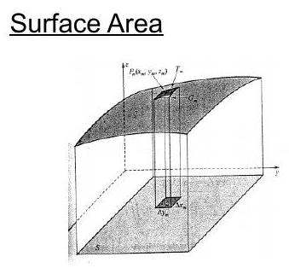

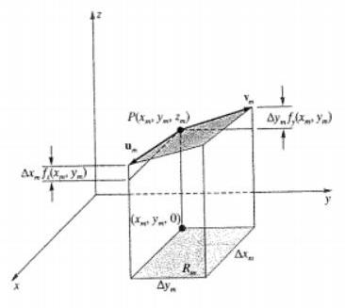

To find the surface area, we are going to add up lots of little areas of parallelograms that are tangent to the surface.
In the limit as $Δx$ and $Δy$ go to zero, the sum becomes an integral which gives the true surface area.
$$\begin{matrix} & {\vec{u}}_{m}=Δx_{m}\overset{ˆ}{i}+f_{x}\left(x_{m},y_{m}\right)Δx_{m}\overset{ˆ}{k}=\left\langle dx_{m},0,f_{x}\left(x_{m},y_{m}\right)dx_{m}\right\rangle \\ & {\vec{v}}_{m}=Δy_{m}\overset{ˆ}{j}+f_{y}\left(x_{m},y_{m}\right)Δy_{m}\overset{ˆ}{k}=\left\langle 0,dy_{m},f_{y}\left(x_{m},y_{m}\right)dy_{m}\right\rangle \end{matrix}$$
We know that the area of the parallelogram is the length of the cross product of its vector sides.

EX 1
Find the surface area of the plane $3x-2y+6z=12$ that is bounded by the planes, $x=0,y=0$, and $3x+2y=12$.

EX 2
Find the surface area for the part of the sphere, $x^{2}+y^{2}+z^{2}=9$, that is inside the circular cylinder, $x^{2}+y^{2}=4$.

EX 3
Find the surface area of $z=4-x^{2}-y^{2}$ over $S=\left\{(x,y)∣x^{2}+y^{2}≤1\right\}$.

For a surface area defined parametrically,
$$\vec{r}(u,v)=⟨f(u,v),g(u,v),h(u,v)⟩$$

EX 4
Find the surface area of a surface given parametrically by
$$\begin{matrix} & \vec{r}(θ,φ)=⟨2sin⁡φcos⁡θ,2sin⁡φsin⁡θ,2cos⁡φ⟩ \\ & R=\{(θ,φ)∣θ∈[0,2π],φ∈[0,π]\}\end{matrix}$$

