Math 2210 #23
Triple Integrals
Triple Integrals

$A=\int_{a}^{b}{ } f(x)dx$ Measures 2-D space (signed area) under a curve above the $x$-axis.
$\begin{matrix} & \\ & V=\iint_{S}{ } f(x,y)dA\end{matrix}$ Measures 3-D space (signed volume) under a surface above the $xy$-plane.

We predict that $\iiint{ }f(x,y,z)dV$ measures 4-D space (signed) under a "hyper" sufface "above" the $xyz$-"hyper-plane".

$$\iiint_{S}{ }f(x,y,z)dV=\int_{a_{1}}^{a_{2}}{ }\int_{φ_{1}(x)}^{φ_{2}(x)}{ }\int_{ψ_{1}(x,y)}^{ψ_{2}(x,y)}{ }f(x,y,z)dzdydx$$

Note: We can't draw anything in 4-D, but we can draw the region S in 3-D (domain space is now 3-D).

EX 1
Write an iterated integral for $\iiint_{S}{ }(y+z+1)dV$
where $S=\{(x,y,z)∣x∈[0,1],y∈[2,5],z∈[1,4]\}$.

EX 2
Evaluate $\int_{0}^{π/2}{ }\int_{0}^{z}{ }\int_{0}^{y}{ }sin⁡(x+y+z)dxdydz$.
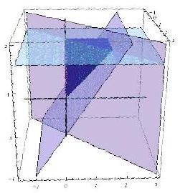

EX 3
Write an iterated integral for $\iiint_{S}{ }f(x,y,z)dV$
where $S$ is the region in the first octant bounded by the surface $z=9-x^{2}-y^{2}$ and the coordinate planes.

EX 4
Find the volume of the solid in the first octant bounded by the hyperbolic cylinder $y^{2}-64z^{2}=4$ and the plane $y=x$ and $y=4$.
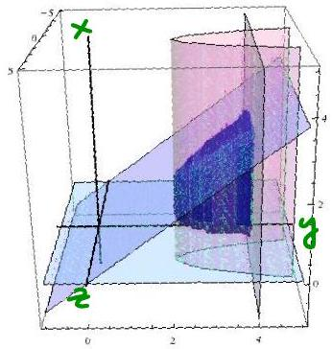

EX 5
Find the volume of the tetrahedron with vertices at $(0,0,0),(0,0,3)$, $(0,4,0)$, and $(2,0,0)$.

