Math 2210 #25
Change of Variables
(Jacobian Method)

Transformations from a region $G$ in the $uv$-plane to the region $R$ in the $xy$-plane are done by equations of the form
$$\begin{matrix} & x=g\left(u,v\right) \\ & y=h\left(u,v\right).\end{matrix}$$
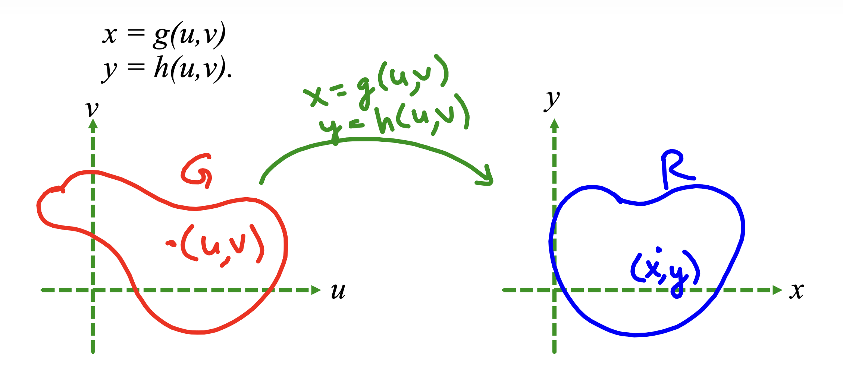

EX 1
$x=\frac{u+v}{2},y=\frac{u-v}{2},G$ is the rectangle given by $\begin{matrix} & 0≤u≤1 \\ & 0≤v≤1\text{.} \end{matrix}$

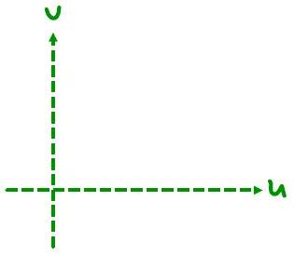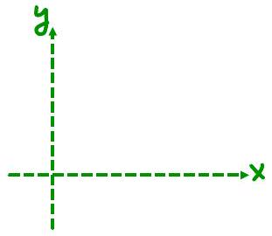
How is the integral of $f\left(x,y\right)$ over $R$ related to the integral of $f\left(g\left(u,v\right),h\left(u,v\right)\right)$ over $G$?
$$\iint_{R}{ }f\left(x,y\right)dxdy=\iint_{G}{ }f\left(g\left(u,v\right),h\left(u,v\right)\right)\left|J\left(u,v\right)\right|dudv$$

where $J\left(u,v\right)=\left|\begin{matrix}\frac{∂x}{∂u} & \frac{∂x}{∂v} \\ \frac{∂y}{∂u} & \frac{∂y}{∂v}\end{matrix}\right|=\frac{∂x}{∂u}\frac{∂y}{∂v}-\frac{∂y}{∂u}\frac{∂x}{∂v}$

EX 2
For polar coordinates, $x=r\cos{θ},y=r\sin{θ}$, what is $J\left(r,θ\right)$ ?
$$J\left(r,θ\right)=\left|\begin{matrix}\frac{∂x}{∂r} & \frac{∂x}{∂θ} \\ \frac{∂y}{∂r} & \frac{∂y}{∂θ}\end{matrix}\right|$$

EX 3
Evaluate $\iint_{R}{ }cos\left(x-y\right)sin\left(x+y\right)dA$ where $R$ is the triangle in the xy-plane with vertices at $\left(0,0\right),$ $\left(π,-π\right)$ and $\left(π,pi\right).$ Use the change of variables $u = x-y$ and
$v = x+y$.

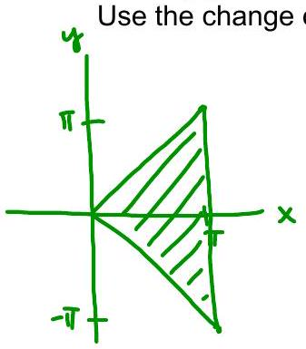

EX 4
Evaluate $\iint_{R}{ }5\left(x^{2}+y^{2}\right)dxdy$ where $R$ is the region in $Q_{I}$ bounded by
$x^{2}+y^{2}=9,x^{2}+y^{2}=16,y^{2}-x^{2}=1,y^{2}-x^{2}=9$.
Hint: Use $u=x^{2}+y^{2}$ and $v=y^{2}-x^{2}$ to transform $R$ into a much nicer region ( $G$ ).
Change of variables in 3 dimensions.
If $x=g\left(u,v,w\right)$
$$y=h\left(u,v,w\right) \\ z=j\left(u,v,w\right)$$then
$$\begin{matrix} & \iiint_{\underline{R}}{ } f\left(x,y,z\right)dxdydz=\iiint_{G}{ } f\left(g\left(u,v,w\right),h\left(u,v,w\right)j\left(u,v,w\right)\right)\left|J\left(u,v,w\right)\right|dudvdw \\ & J\left(u,v,w\right)=\left|\begin{matrix}\frac{∂x}{∂u} & \frac{∂x}{∂v} & \frac{∂x}{∂w} \\ \frac{∂y}{∂u} & \frac{∂y}{∂v} & \frac{∂y}{∂w} \\ \frac{∂z}{∂u} & \frac{∂z}{∂v} & \frac{∂z}{∂w}\end{matrix}\right|\end{matrix}$$

EX 5
Let's check the Jacobian for spherical
coordinates.
$$\begin{matrix} & x=ρ\cos{θ}\sin{φ} \\ & y=ρ\sin{θ}\sin{φ} \\ & z=ρ\cos{φ} \\ & J\left(ρ,θ,φ\right)=\left|\begin{matrix}\frac{∂x}{∂ρ} & \frac{∂x}{∂θ} & \frac{∂x}{∂φ} \\ \frac{∂y}{∂ρ} & \frac{∂y}{∂θ} & \frac{∂y}{∂φ} \\ \frac{∂z}{∂ρ} & \frac{∂z}{∂θ} & \frac{∂z}{∂φ}\end{matrix}\right|\end{matrix}$$

