Math 2210 #27
Line Integrals

Let's review parameterization of curves.

The length of a parameterized curve in 2-D $(x(t),y(t)),t∈[a,b]$ is given by
$$L=\int_{a}^{b}{ }\sqrt{{\left(\frac{dx}{dt}\right)}^{2}+{\left(\frac{dy}{dt}\right)}^{2}}dt$$
In 3-D if $\vec{r}(t)=x(t)\overset{ˆ}{i}+y(t)\overset{ˆ}{j}+z(t)\overset{ˆ}{k}$,
then the length of a curve is
$$L=\int_{a}^{b}{ }\sqrt{{\left(\frac{dx}{dt}\right)}^{2}+{\left(\frac{dy}{dt}\right)}^{2}+{\left(\frac{dz}{dt}\right)}^{2}}dt$$
Suppose $f(x,y)$ is a function whose domain contains the curve
$C:\vec{r}(t)=x(t)\overset{ˆ}{i}+y(t)\overset{ˆ}{j}, t∈[a,b]$.
The line integral of $f$ along the curve $C$ from $a$ to $b$ is defined as $\int_{C}{f\left(x,y\right)ds}$, where
ds = arc length differential.
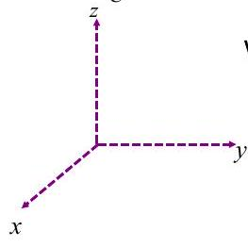
We know that $ds=\sqrt{{\left(\frac{dx}{dt}\right)}^{2}+{\left(\frac{dy}{dt}\right)}^{2}}dt$

Line integral $=\int_{a}^{b}{ }f(x(t),y(t))\sqrt{{\left(\frac{dx}{dt}\right)}^{2}+{\left(\frac{dy}{dt}\right)}^{2}}dt=\int_{C}{ }f(x,y)ds$

In 3 variables
$$\begin{matrix}\int_{C}{ } f(x,y,z)ds & =\int_{a}^{b}{ } f(x(t),y(t),z(t))|\vec{v}(t)|dt \\ & =\int_{a}^{b}{ } f(x(t),y(t),z(t))\sqrt{{\left(\frac{dx}{dt}\right)}^{2}+{\left(\frac{dy}{dt}\right)}^{2}+{\left(\frac{dz}{dt}\right)}^{2}}dt\end{matrix}$$
where
$$\begin{matrix}\vec{r}(t) & =x(t)\overset{ˆ}{i}+y(t)\overset{ˆ}{j}+z(t)\overset{ˆ}{k} \\ \vec{v}(t) & =x^{'}(t)\overset{ˆ}{i}+y^{'}(t)\overset{ˆ}{j}+z^{'}(t)\overset{ˆ}{k}\end{matrix}$$

EX 1
The figure shows two different paths, $C_{1}∪C_{2}$ and $C_{3}$.
Find $\int_{C_{3}}{ }\left(x-3y^{2}+z\right)ds$ and $\int_{C_{1}∪C_{2}}{ }\left(x-3y^{2}+z\right)ds$.
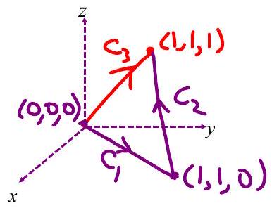

EX 2
A thin wire is bent in the shape of the semicircle
$$\begin{matrix} & x=acos⁡t, t∈[0,π], a>0 \\ & y=asin⁡t\end{matrix}$$
If the density of the wire is proportional to the distance from the $x$-axis, find the mass of the wire.

Work
The goal is to calculate the work done by a vector field $\vec{F(x,y,z)}$ in moving an object along a curve $C$ with parameterization.
$$C:\overset{⇀}{r}(t)=x(t)\overset{ˆ}{i}+y(t)\overset{ˆ}{j}+z(t)\overset{ˆ}{k},t∈[a,b]$$

The work done to move the object at $(x,y,z)$ by a small vector, $Δ\vec{r}$ is
$$\begin{matrix}ΔW=\vec{F}(x,y,z)⋅Δ'\vec{r}(x,y,z) \\ W=\int_{C}{ } \vec{F}⋅d\vec{r}\end{matrix}$$

Formula for calculating work
If $\vec{F}=M\overset{ˆ}{i}+N\overset{ˆ}{j}+P\overset{ˆ}{k}$
$$\begin{matrix}\vec{r}(t) & =x(t)\overset{ˆ}{i}+y(t)\overset{ˆ}{j}+z(t)\overset{ˆ}{k} \\ d\vec{r} & =dx\overset{ˆ}{i}+dy\overset{ˆ}{j}+dz\overset{ˆ}{k}\end{matrix}$$
where
$$\begin{matrix} & M=M(x,y,z) \\ & N=N(x,y,z) \\ & P=P(x,y,z)\end{matrix}$$
then $W=\int_{C}{ }\vec{F}⋅d\vec{r}=$

EX 3
Find the work done by an inverse square law force field
$$\vec{F}\left(x,y,z\right)=\frac{-c\left(x\overset{ˆ}{i}+y\overset{ˆ}{j}+z\overset{ˆ}{k}\right)}{\sqrt{x^{2}+y^{2}+z^{2}}}$$
in moving a particle along the straight line curve
from $(0,3,0)$ to $(4,3,0)$.
Note: If $c>0$, then the work done is negative.

EX 4
Evaluate $∫_{C} (2x+9z)ds$, where $C$ is the curve given by
$$x=t,y=t^{2},z=t^{3}, t∈[0,1]$$

EX 5
Evaluate $\int_{C}{ }\left(ydx+x^{2}dy\right)$, where $C$ is the curve given by
$$x=2t,y=t^{2}-1,t∈[0,2]$$

