Math 2210 #2
Cartesian Coordinates in 3-Space
A point in 3 -space is given by an ordered triple $\left(x,y,z\right)$.
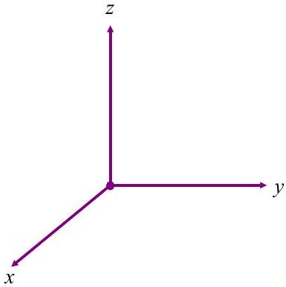

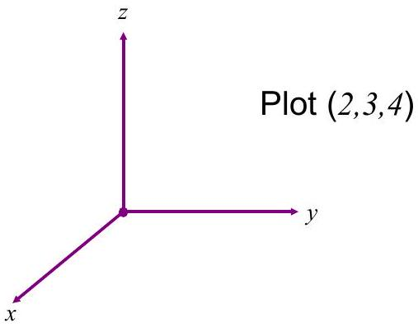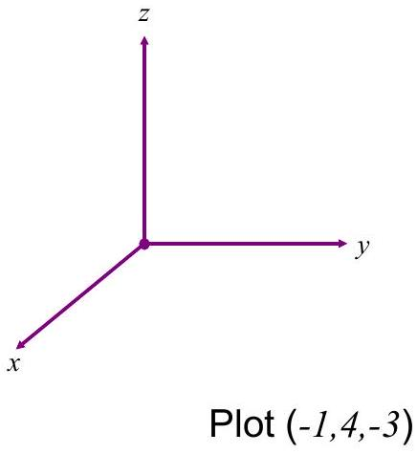

Distance Formula $d^{2}=(Δx)^{2}+(Δy)^{2}+(Δz)^{2}$
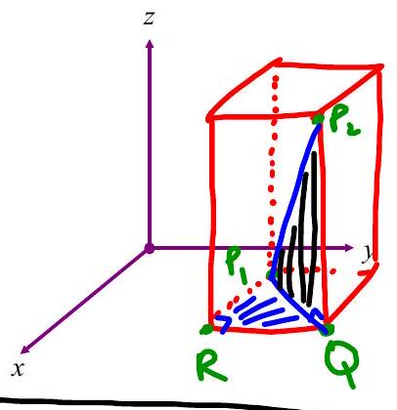
note: $P_{1}Q$ means length of line segment from $P_{1}$ to Q
$△P_{1}P_{2}Q$ and $△P_{1}QR$ are both right triangles.
⇒ can use Pythagovean Thm ${\left|P_{1}Q\right|}^{2}+{\left|QP_{2}\right|}^{2}={\left|P_{1}P_{2}\right|}^{2}$ (1)
and ${\left|P_{1}R\right|}^{2}+|RQ|^{2}={\left|P_{1}Q\right|}^{2}$ (2)
⇒ sub (2) into (1)

EX 1
Show that these points are vertices of an equilateral triangle.
$$\left(4,5,3\right),\left(1,7,4\right),\left(2,4,6\right)$$

Spheres All points $\left(x,y,z\right)$ on a sphere are a fixed distance, $r$ from the center.
$$r=\sqrt{(x-h)^{2}+(y-k)^{2}+(z-l)^{2}}$$
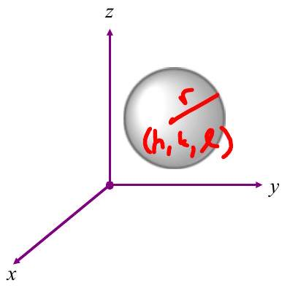
So the equation of a sphere with radius $r$ and center ( $h,k,l$ ) is
$$r^{2}=(x-h)^{2}+(y-k)^{2}+(z-l)^{2}$$
Midpoint of the segment ( $x_{1},y_{1},z_{1}$ ) and ( $x_{2},y_{2},z_{2}$ )
$$m=\left(\frac{x_{1}+x_{2}}{2},\frac{y_{1}+y_{2}}{2},\frac{z_{1}+z_{2}}{2}\right)$$

EX 2

2a)
Find the center and radius of this sphere.
$$x^{2}+y^{2}+z^{2}+2x-6y-10z+34=0$$

2b)
Find the equation of the sphere that has a diameter from (-4,2,1) to (8,3,6).

Linear equations in 3-space
$$Ax+By+Cz=D$$

EX 3
Graph $3x-4y+2z=24$.
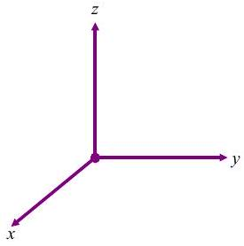

EX 4
Graph $3x+4y=12$.
