Math 2210 #30
Surface Integrals
Surface Integrals
Let $G$ be defined as some surface, $z=f(x,y)$.
The surface integral is defined as
$$\iint_{G}{ }g(x,y,z)dS, \text{where} dS \text{is a "little bit of surface area."}$$
To evaluate we need this Theorem:
Let $G$ be a surface given by $z=f(x,y)$ where $(x,y)$ is in $R$, a bounded, closed region in the $xy$-plane.
If $f$ has continuous first-order partial derivatives and $g(x,y,z)=g(x,y,f(x,y))$ is continuous on $R$, then
$$\iint_{G}{ }g(x,y,z)dS=\iint_{R}{ }g(x,y,f(x,y))\sqrt{f_{x}^{2}+f_{y}^{2}+1}dydx$$

EX 1
Evaluate $\iint_{G}{ }g(x,y,z)dS$ given by $g(x,y,z)=x$, and $G$ is the plane
$$x+y+2z=4,x∈[0,1],y∈[0,1].$$

EX 2
Evaluate $\iint_{G}{ }\left(2y^{2}+z\right)dS$ where $G$ is the surface
$$z=x^{2}-y^{2}, \text{with} R \text{given by} 0≤x^{2}+y^{2}≤1.$$
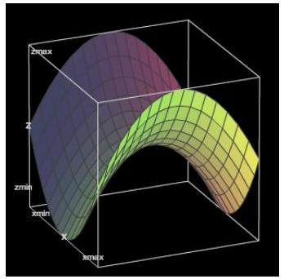

EX 3
Evaluate $\iint_{G}{ }g(x,y,z)dS$ where $g(x,y,z)=z$ and $G$ is the tetrahedron bounded by the coordinate planes and the plane $4x+8y+2z=16$.

Theorem
Let $G$ be a smooth, two-sided surface given by $z=f(x,y)$, where $(x,y)$ is in $R$ and let $\vec{n}$ denote the upward unit normal on $G$. If $f$ has continuous first-order partial derivatives and $\vec{F}=M\overset{ˆ}{i}+N\overset{ˆ}{j}+P\overset{ˆ}{k}$ is a continuous vector field, then the flux of $\vec{F}$ across $G$ is given by
$$\text{flux} \vec{F}=\iint_{G}{ }\vec{F}⋅\vec{n}dS=\iint_{R}{ }\left[-Mf_{x}-Nf_{y}+P\right]dxdy$$

EX 4
Evaluate the flux of $\vec{F}$ across $G$ where
$\vec{F}(x,y,z)=\left(9-x^{2}\right)\overset{ˆ}{j}$ and $G$ is the part of the plane
$2x+3y+6z=6$ in the first octant.

