Math 2210 #3
A Geometric and Algebraic Approach to Vectors

VECTORS (Geometric Approach)
Scalar

Vector

Magnitude

Direction
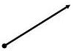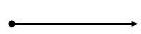
$\vec{u}=\vec{v}$ if they have the same magnitude and direction.
zero vector $⇒\vec{0}$ and $\vec{0}+\vec{u}=\vec{u}+\vec{0}=\vec{u}$
$$-\vec{u} ⇒$$
scalar multiple of $\vec{u}⇒c\vec{u}$, where $c$ is a real number, means we have a vector in the direction of $\vec{u}$ but scaled in length.
Adding vectors $⇒\vec{u}+\vec{v}$
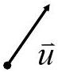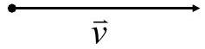

EX 1
Express $w$ in terms of $u$ and $v$.
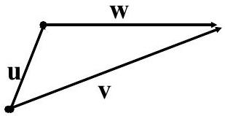

EX 2
Draw $w$ where $w=v_{1}+v_{2}+v_{3}$
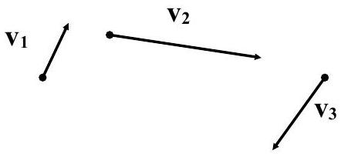

EX 3
Mark pushes on a post in the direction $S{30}^{∘}E$ with a force of 60 lbs. Dan pushes on the same post in the direction $S{60}^{∘}W$ with a force of 80 lbs. What are the magnitude and direction of the resulting force?

EX 4
A ship is sailing due south at 20 mph. A man walks west across the deck at 3 mph. What are the magnitude and direction of his velocity relative to the surface of the water?

Vectors (Algebraic approach)
If we place our vector on a Cartesian Coordinate system with its tail at the origin, then its head will end at some point ( $u_{l},u_{2},u_{3}$ ). We say that $u=\left\langle u_{l},u_{2},u_{3}\right\rangle u_{1},u_{2}$ and $u_{3}$ are called components of $u$.
$$\begin{matrix} & u=v \text{iff} u_{1}=v_{1},u_{2}=v_{2}\text{, and} u_{3}=v_{3} \\ & u+v=\left\langle u_{l},u_{2},u_{3}\right\rangle +\left\langle v_{l},v_{2},v_{3}\right\rangle =\left\langle u_{1}+v_{l},u_{2}+v_{2},u_{3}+v_{3}\right\rangle \\ & -u=\left\langle -u_{l},-u_{2},-u_{3}\right\rangle cu=\left\langle cu_{l},cu_{2},cu_{3}\right\rangle \\ & 0=0u=\left\langle 0,0,0\right\rangle \end{matrix}$$

Theorem A
For all vectors $u,v,w$ and the real numbers $a$ and $b$
$$u+v=v+u$$
$$\left(u+v\right)+w=u+\left(v+w\right)$$
$$u+0=0+u$$
$$u+-u=0$$
$$a\left(bu\right)=\left(ab\right)u$$
$$a\left(u+v\right)=au+av$$
$$\left(a+b\right)u=au+bu$$
$$1u=u$$

$$\begin{matrix} & \left\|u\right\|=\sqrt{u_{1}^{2}+u_{2}^{2}+u_{3}^{2}} \\ & \left\|cu\right\|=\left|c\right|\left\|u\right\|\end{matrix}$$

EX 5
Let $u=\left\langle -1,5,2\right\rangle$, find $\left\|u\right\|$ and $\left\|-3u\right\|$.
Also, find a vector, $\overset{ˆ}{u}$ with the same direction as $u$ but with magnitude $=1$. (This is called a unit vector)

