Math 2210 #4
The Dot Product

EX 1

1a)
Write a vector represented by $\vec{AB}$ in the form $\vec{a}=a_{1}\overset{ˆ}{i}+a_{2}\overset{ˆ}{j}+a_{3}\overset{ˆ}{k}$.
A ( $-2,3,5$ )
B $\left(1,-2,4\right)$

1b)
Find a unit vector $\vec{u}$ in the direction of $\left\langle -3,5,6\right\rangle$ and express it in the form $\vec{u}=u_{1}\overset{ˆ}{i}+u_{2}\overset{ˆ}{j}+u_{3}\overset{ˆ}{k}$

The dot product is one type of multiplication between vectors that returns a scalar (number).
For $\vec{u}=\left\langle u_{1},u_{2},u_{3}\right\rangle$ and $\vec{v}=\left\langle v_{1},v_{2},v_{3}\right\rangle$,
$$\overset{⇀}{u}⋅\overset{⇀}{v}=u_{1}v_{1}+u_{2}v_{2}+u_{3}v_{3}.$$

Theorem A
Let $\vec{u},\vec{v},\vec{w}$ be vectors and $c$ a real number.

$$\begin{matrix} & \vec{u}⋅\vec{v}=\vec{v}⋅\vec{u} \\ & \vec{u}⋅\left(\vec{v}+\vec{w}\right)=\vec{u}⋅\vec{v}+\vec{u}⋅\vec{w} \\ & c\left(\vec{u}⋅\vec{v}\right)=\left(c\vec{u}\right)⋅\vec{v}=\vec{u}⋅\left(c\vec{v}\right) \\ & \vec{0}⋅\vec{u}=0 \\ & \vec{u}⋅\vec{u}=‖\vec{u}‖^{2}\end{matrix}$$

Theorem B
Geometrically, we can think of the dot product as $\vec{u}⋅\vec{v}=\left\|\vec{u}\right\|\left\|\vec{v}\right\|cos{θ}$ where $θ$ is the angle between $\vec{u}$ and $\vec{v}$.

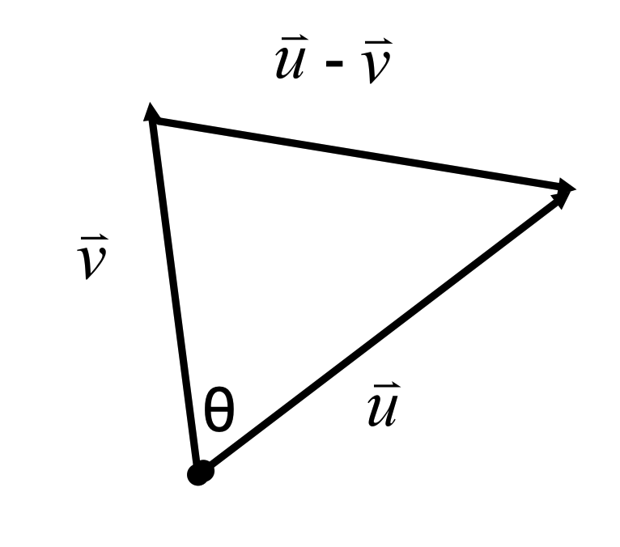

Theorem C
The vectors $\vec{u}$ and $\vec{v}$ are perpendicular iff $\vec{u}⋅\vec{v}=0$.
Perpendicular vectors are called orthogonal.

EX 2
For what number c are these vectors perpendicular?
$$\left\langle 2c,-8,1\right\rangle \text{and} \left\langle 3,c,-2+c\right\rangle$$

EX 3
Find the angle between $\vec{u}=4\overset{ˆ}{i}+2\overset{ˆ}{j}+3\overset{ˆ}{k}$ and $\vec{v}=2\overset{ˆ}{i}+\overset{ˆ}{j}+5\overset{ˆ}{k}$.

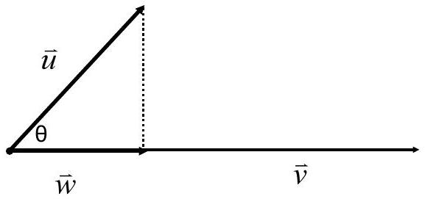

EX 4
Let $\vec{u}=\left\langle 1,6,-2\right\rangle$ and $\vec{v}=\left\langle -3,2,5\right\rangle$. Find the vector projection of $\vec{u}$ onto $\vec{v}$.

EX 5
If $\vec{u}=e\overset{ˆ}{i}+π\overset{ˆ}{j}+\overset{ˆ}{k}$ and $\vec{v}=\left\langle 1,1,0\right\rangle$, express $\vec{u}$ as the sum of vectors $\vec{m}$ and $\vec{n}$, such that $\vec{m}‖\vec{v}$ and $\vec{n}⊥\vec{v}$.

Planes
Given a plane with normal vector $\vec{n}= \left\langle A, B, C \right\rangle$
and a point $P_{1}\left(x_{1},y_{1},z_{1}\right)$ in the plane, every
other point $P\left(x,y,z\right)$in the plane will satisfy $\vec{P_{1}P}⋅\vec{n}=0$.

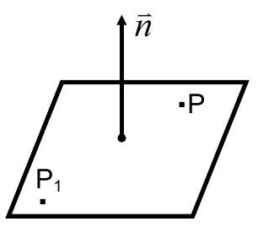

EX 6
Find the equation of a plane that goes through the origin with normal vector
$\vec{n}=<1,2,3>$.

EX 7
Find the equation of the plane through ( $1,-3,4$ ) perpendicular to
$$\vec{n}=\left\langle -1,2,-1\right\rangle .$$
Note:
For any given plane, the most important feature of the normal vector is the direction.
Therefore, we can use any scaled version of the normal vector when determining the equation of a plane.

Distance from a point $P_{0}\left(x_{0},y_{0},z_{0}\right)$ to a plane $Ax+By+Cz=D$
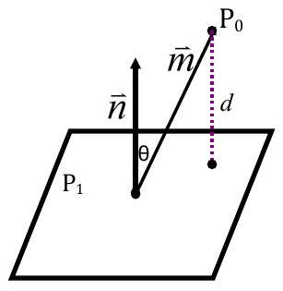

EX 8
Find the distance between the parallel planes
$$-3x+2y+z=9 \text{and} 6x-4y-2z=19$$

EX 9
Find the (smaller) angle between the two planes,
$$-3x+2y+5z=7 \text{and} 4x-2y-3z=2$$

