Math 2210 #6
Vector-Valued Functions and Curvilinear Motion

A vector-valued function associates a vector output, $\vec{F}(t)$, to a scalar input.
i.e $\vec{F}(t)=f(t)\overset{ˆ}{i}+g(t)\overset{ˆ}{j}=⟨f(t),g(t)⟩$ (in 2D)
where $f$ and $g$ are real-valued functions of $t$
or (in 3D).

Definition
$\lim_{t→c} \vec{F}(t)=\vec{L}$ means that for every $ε>0$ there is a corresponding $δ>0$ such that $‖\vec{F}(t)-\vec{L}‖<ε$, provided $0<|t-c|<δ$, i.e.
$$0<|t-c|<δ⇒‖\vec{F}(t)-\vec{L}‖<ε$$

Theorem A
Let $\vec{F}(t)=f(t)\overset{ˆ}{i}+g(t)\overset{ˆ}{j}$. Then $\vec{F}$ has a limit at c iff $f$ and $g$ have limits at $c$ and
$$\lim_{t→c} \vec{F}(t)=\left[\lim_{t→c} f(t)\right]\overset{ˆ}{i}+\left[\lim_{t→c} g(t)\right]\overset{ˆ}{j}$$

Continuity $⇒\vec{F}(t)$ is continuous at $t=c$ if $\lim_{t→c} \vec{F}(t)=\vec{F}(c)$.
Derivative $⇒{\vec{F}}^{'}(t)=\lim_{h→0} \frac{\vec{F}(t+h)-\vec{F}(t)}{h}$

Differentiation Formulas
$\overset{⇀}{F}(t) \& \overset{⇀}{G}(t)$ are differentiable $c∈R$, $h\left(t\right)$ is differentiable
- $D_{t}[\vec{F}(t)+\vec{G}(t)]={\vec{F}}^{'}(t)+{\vec{G}}^{'}(t)$
- $D_{t}[c\vec{F}(t)]=c{\vec{F}}^{'}(t)$
- $D_{t}[h(t)⋅\vec{F}(t)]=h(t)⋅{\vec{F}}^{'}(t)+h^{'}(t)⋅\vec{F}(t)$
- $D_{t}[\vec{F}(t)⋅\vec{G}(t)]=\vec{F}(t)⋅{\vec{G}}^{'}(t)+{\vec{F}}^{'}(t)⋅\vec{G}(t)$
- $D_{t}[\vec{F}(h(t))]={\vec{F}}^{'}(h(t))⋅h^{'}(t)$

Integration Formula
$$\int{ }\vec{F}(t)dt=\left[\int{ }f(t)dt\right]\overset{ˆ}{i}+\left[\int{ }g(t)dt\right]\overset{ˆ}{j}$$

EX 1
Find
$$\lim_{t→∞} \left[\frac{tsin⁡t}{t^{2}}\overset{ˆ}{i}-\frac{7t^{3}}{t^{3}-3t}\overset{ˆ}{j}\right]$$

EX 2
Find ${\vec{F}}^{'}(x)$ and ${\vec{F}}^{''}(x)$ for $\vec{F}(x)=\left(e^{x}+e^{-x^{2}}\right)\overset{ˆ}{i}+cos⁡(2x)\overset{ˆ}{j}$.

EX 3
$$\hat{f}(y)=\left(\tan^{2}⁡y\right)\hat{i}+\sin^{2}⁡\left(\tan^{2}⁡y\right)\hat{j}+3y\hat{k}$$Find ${\vec{f}}^{'}(y)$.

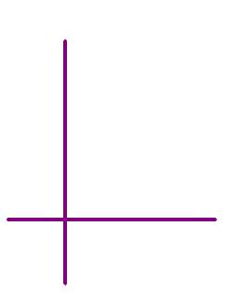
$\vec{r}(t)$ is position vector at any time $t$ along a curve given by
$$x=x(t) \text{and} y=y(t).$$
$$\begin{matrix} & \vec{r}\left(t\right)=x\left(t\right)\overset{ˆ}{i}+y\left(t\right)\overset{ˆ}{j} \\ & \vec{v}\left(t\right)={\vec{r}}^{'}\left(t\right)=x^{'}\left(t\right)\overset{ˆ}{i}+y^{'}\left(t\right)\overset{ˆ}{j} \\ & \vec{a}\left(t\right)={\vec{v}}^{'}\left(t\right)={\vec{r}}^{''}\left(t\right)=x^{''}\left(t\right)\overset{ˆ}{i}+y^{''}\left(t\right)\overset{ˆ}{j}\end{matrix}$$

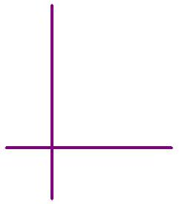

EX 4
Given $\vec{r}(t)=(4sin⁡t)\overset{ˆ}{i}+(8cos⁡t)\overset{ˆ}{j}$,

4a)
Find $\vec{v}(t)$ and $\vec{a}(t)$.

4b)
Find the speed when $t=π/4$.
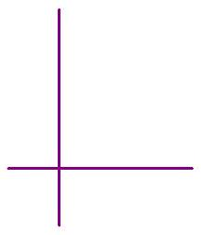

4c)
Sketch a portion of the graph of $\vec{r}(t)$ containing the position $P$ of the particle at $t=π/4$. Draw $\vec{v}$ and $\vec{a}$ at $P$ as well.

EX 5
Suppose that an object moves around a circle with center at $(0,0)$ and radius $r$ at a constant angular speed of $ω$ radians/sec. If its initial position is $(0,r)$, find its acceleration.

