Math 2210 #8
Surfaces in Three-Space

Quick Review of the Conic Sections
a) Parabola $y=x^{2}$ and $x=y^{2}$
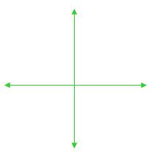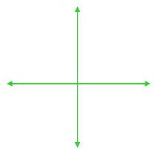
b) Ellipse $\frac{x^{2}}{a^{2}}+\frac{y^{2}}{b^{2}}=1$
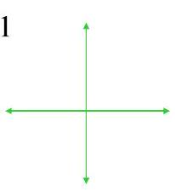

c) Hyperbola $\frac{x^{2}}{a^{2}}-\frac{y^{2}}{b^{2}}=1$ and $\frac{y^{2}}{b^{2}}-\frac{x^{2}}{a^{2}}=1$
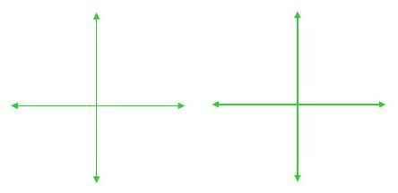

Surfaces in Three-Space
The graph of a 3 -variable equation which can be written in the form $F(x,y,z)=0$ or sometimes $z=f(x,y)$ (if you can solve for $z$ ) is a surface in 3D. One technique for graphing them is to graph cross-sections (intersections of the surface with well-chosen planes) and/or traces (intersections of the surface with the coordinate planes).
We already know of two surfaces:
a) plane $Ax+By+Cz=D$
b) sphere $(x-h)^{2}+(y-k)^{2}+(z-l)^{2}=r^{2}$
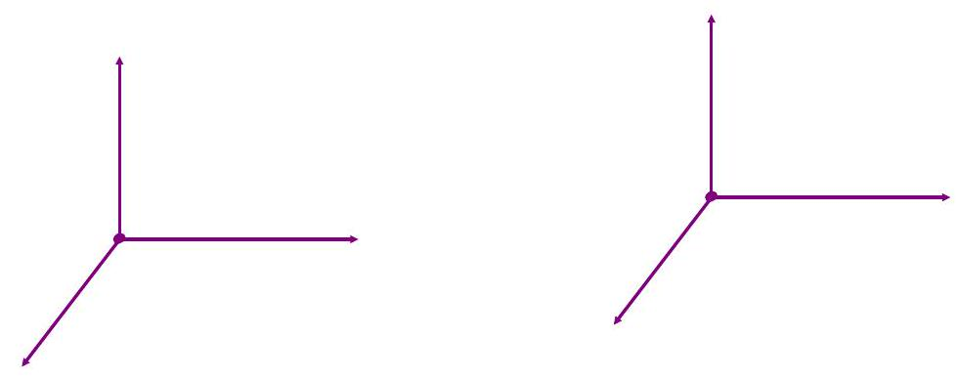

EX 1
Sketch a graph of $z=x^{2}+y^{2}$ and $x=y^{2}+z^{2}$.
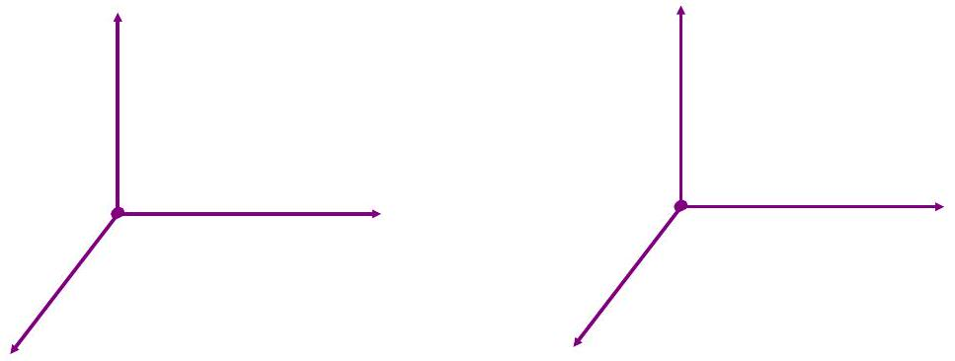

A cylinder is the set of all points on lines parallel to $l$ that intersect C where C is a plane curve and $l$ is a line intersecting C, but not in the plane of C

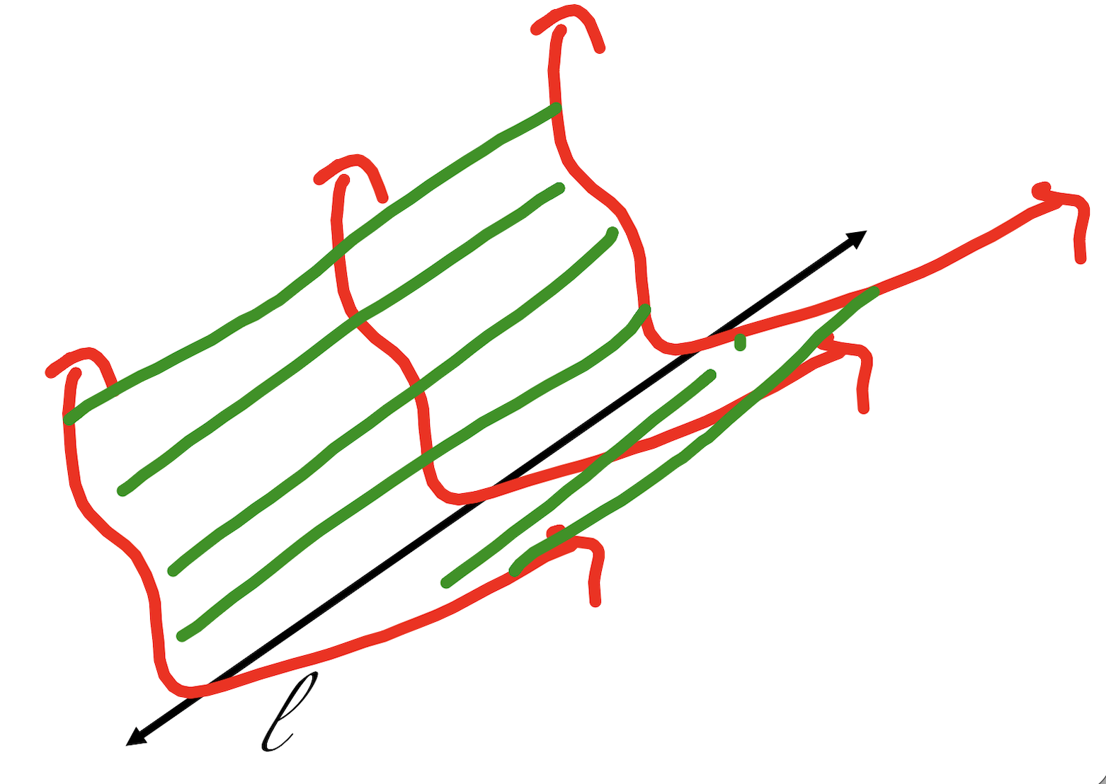

A Quadric Surface is a 3D surface whose equation is of the second degree.
The general equation is
$Ax^{2}+By^{2}+Cz^{2}+Dxy+Exz+Fyz+Gx+Hy+Iz+J=0$,
given that $A^{2}+B^{2}+C^{2}≠0$.
With rotation and translation, these possibilities can be reduced to two distinct types.
- $Ax^{2}+By^{2}+Cz^{2}+J=0$
- $Ax^{2}+By^{2}+Iz=0$

Basic Quadric Surfaces

ELLIPSOID
$$\frac{x^{2}}{a^{2}}+\frac{y^{2}}{b^{2}}+\frac{z^{2}}{c^{2}}=1$$
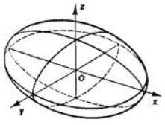

HYPERBOLOID OF ONE SHEET
$$\frac{x^{2}}{a^{2}}+\frac{y^{2}}{b^{2}}-\frac{z^{2}}{c^{2}}=1$$
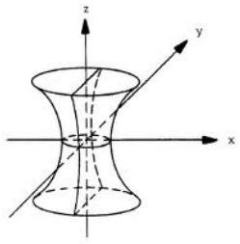

HYPERBOLOID OF TWO SHEETS
$$\frac{x^{2}}{a^{2}}-\frac{y^{2}}{b^{2}}-\frac{z^{2}}{c^{2}}=1$$
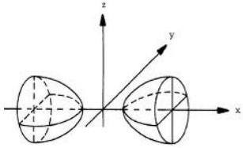

ELLIPTIC PARABOLOID
$$z=\frac{x^{2}}{a^{2}}+\frac{y^{2}}{b^{2}}$$
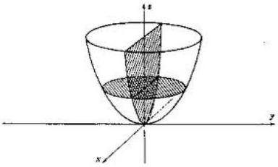

HYPERBOLIC PARABOLOID
$$z=\frac{y^{2}}{b^{2}}-\frac{x^{2}}{a^{2}}$$
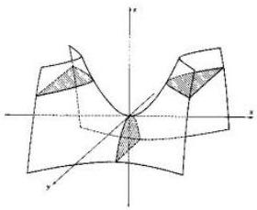

ELLIPTIC CONE
$$\frac{x^{2}}{a^{2}}+\frac{y^{2}}{b^{2}}-\frac{z^{2}}{c^{2}}=0$$
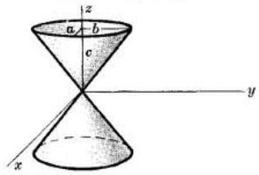

EX 2
Name and sketch these graphs

2a)
$9x^{2}+y^{2}-z^{2}=-4$
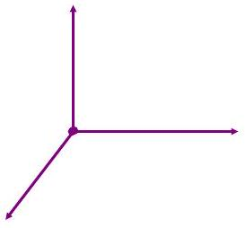

2b)
$$9x^{2}+y^{2}-z^{2}=4$$
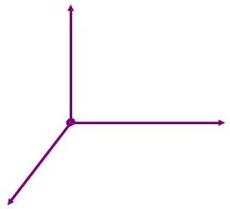

2c)
$$x^{2}+4y^{2}-z=0$$
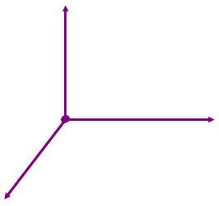

2d)
$$x^{2}+y^{2}=1$$
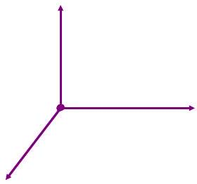

2e)
$$x^{2}-y^{2}=25$$
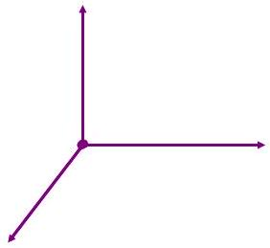

2f)
$$z=y^{2}$$
