Math 2210 #9
Cylindrical and Spherical Coordinates

We can describe a point, $P$, in three different ways.
Cartesian | Cylindrical | Spherical
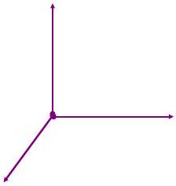

Cylindrical Coordinates
$$x=rcos⁡θ \\ y=rsin⁡θ \\ z=z$$
$$\begin{matrix} & r=\sqrt{x^{2}+y^{2}} \\ & tan⁡θ=y/x \\ & z=z\end{matrix}$$

Spherical Coordinates
$$x=ρsin⁡φcos⁡θ \\ y=ρsin⁡φsin⁡θ \\ z=ρcos⁡φ$$
$$\begin{matrix} & ρ=\sqrt{x^{2}+y^{2}+z^{2}} \\ & tan⁡θ=y/x \\ & cos⁡φ=\frac{z}{\sqrt{x^{2}+y^{2}+z^{2}}}\end{matrix}$$

Easy Surfaces in Cylindrical Coordinates
- $r=1$
- $θ=π/3$
- $z=4$
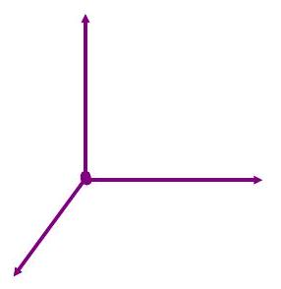

Easy Surfaces in Spherical Coordinates
- $ρ=1$
- $θ=π/3$
- C) $φ=π/4$

EX 1
Convert the coordinates as indicated

1a)
( $3,π/3,-4$ ) from cylindrical to Cartesian.

1b)
(-2, 2,3) from Cartesian to cylindrical.

EX 2
Convert the coordinates as indicated

2a)
( $8,π/4,π/6$ ) from spherical to Cartesian.

2b)
$(2\sqrt{3},6,-4)$ from Cartesian to spherical.

EX 3
Convert from cylindrical to spherical coordinates.
( $1,π/2,1$ )

EX 4
Make the required change in the given equation.

4a)
$x^{2}-y^{2}=25$ to cylindrical coordinates.

4b)
$x^{2}+y^{2}-z^{2}=1$ to spherical coordinates.

4c)
$ρ=2cos⁡φ$ to cylindrical coordinates.

EX 4
Make the required change in the given equation (continued).

4d)
$x+y+z=1$ to spherical coordinates.

4e)
$r=2sin⁡θ$ to Cartesian coordinates.

4f)
$ρsin⁡θ=1$ to Cartesian coordiantes.

